# Build a Cloud-native Web App to Manage Product Reviews using API Gateway, Aurora, and RDS proxy

Created by[Chandra Lingam](https://deloittedevelopment.udemy.com/user/e7c3b177-f449-448a-aff8-9ef970b23152/)

**AWS Workspace**

**120-180 minutes**

In this lab, you are a software developer building a web app for managing products and their reviews. The company you work for is new to the cloud. Your tech lead has asked you to build a proof-of-concept using AWS serverless compute offering such as Lambda for the application logic with data stored in an Aurora relational database. The solution you create must minimize the infrastructure footprint with elasticity to handle changes in traffic.

Our applications are currently hosted on on-premises servers, and the application traffic is unpredictable. So, we often end up with idling servers or over-utilized servers. As part of the cloud migration, we are looking at a cloud-native solution that can dynamically scale based on traffic. We also want to minimize expenses when there is no application traffic. As our team is new to AWS cloud, we want to build a proof-of-concept application and learn from it. You will build a micro-service for managing products and reviews. You will use API Gateway as the "front door" Lambda for the application logic, and Aurora Relational database for data storage. For hosting the web page, you will use Amazon S3.

The web page must use client-side JavaScript to interact with your API Gateway. For connection-pooling, your Lambda function must use RDS Proxy to talk to the database. You should maintain the database login credentials in AWS Secrets Manager, and RDS Proxy must use these credentials to connect to the database. Your Lambda function would acquire a connection from RDS Proxy using IAM Role. In this solution, only Aurora is server-based, and the rest of the application uses serverless technologies.

**How you'll work**

Your project has been broken into a set of tasks. To complete these tasks, use the provided workspace. You can launch your workspace by clicking below or using the button in the top right of the screen.

TASK

1-Design able for storing products and reviews(botto-up)

2-design resource and HTTP methods for API (top-down)

3-Launch Aurora database instance in default VPC

4-Configure Secrets Manager to store datsbase crendential

5-Launch RDS proxy in default VPC

6 Create a Lamba Layer for python pymysql library and IAM role for Lambda function

7-Create a health check Lambda function to test database connectivity,create table, and populate data

8-Integrate database Proxy and Lambda layer with health check lambda function

9-Invoke health check function

10-implement CRUD backend functionality

11-Integrate Database proxy and Lambda layer with the produc review function

12-Create an HTTP API Gateway

13-Integrate Test using API Gateway

14-configure a bucket in S3 to host your website

15-Upload webpage to S3

16-Visit the product-review website and test all features

17Clean Up

Design able for storing products and reviews(botto-up)

You need to design relational tables for storing products and reviews. There could be many products; each product could have several reviews. So, design two tables, one for "product" and another for "review". Ensure design allows a review only for existing products. You should use Aurora-MySQL data types.

1. Create a product table and add columns for the product category and product title
2. Include primary key to uniquely identify a product
3. Include sum of ratings and count of ratings in the product table to find the average rating
4. Here is what your Product table design table should look like:

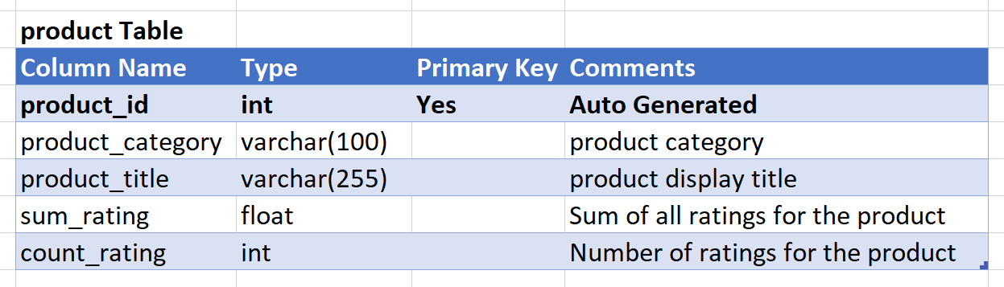

1. Create a review table, and include a foreign key to refer to the product
2. Add a date-time column to record when a review was added
3. You also need columns for review headline and body
4. Finally, add a column for rating given by the reviewer
5. Your Review table should look like this:

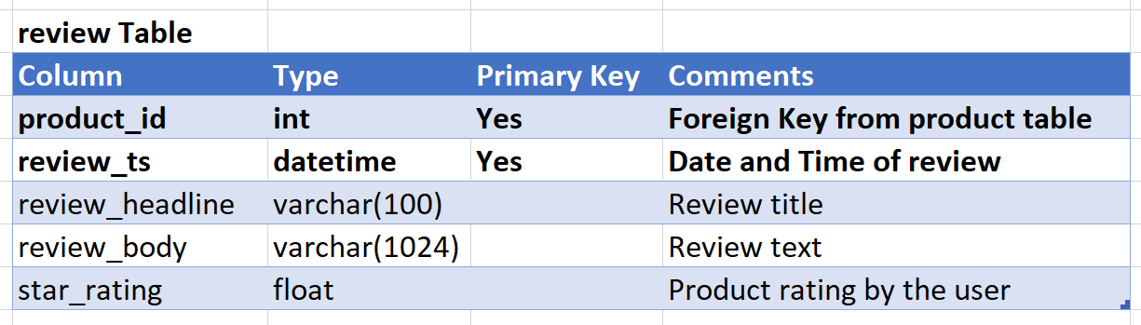

<https://www.w3schools.com/mysql/mysql_create_table.asp>

<https://www.w3schools.com/mysql/mysql_datatypes.asp>

<https://www.w3schools.com/mysql/mysql_autoincrement.asp>

Design resource and HTTP methods for API (top-down)

You will need to design a RESTful API for CRUD (Create Read Update Delete) of products and reviews. The API must allow a client application to view and manage products and reviews

1. For the API, create two resources: **products**, and **reviews**
2. For CRUD operations, use the HTTP methods **GET, POST, PUT, DELETE**
3. Include methods to read all products, to read a specific product, create a new product, update an existing product, delete an existing product
4. Include methods to read reviews for a specific product, create a new review, and to read a specific review for a product
5. Add a query string parameter to limit the number of results returned in a call and to filter the reviews by rating
6. Your API design would now consist of the following resources and methods:
7. GET /products # Read all products
8. GET /products?limit=10 # Read specified number of products
9. GET /products/{productId} # Read specified product
10. POST /products # Create a new product
11. PUT /products # Update an existing product
12. DELETE /products/{productId} # Delete an existing product
13. GET /products/{productId}/reviews # Read all reviews for a product
14. GET /products/{productId}/reviews?star_rating=4 # Read reviews with specified star rating
15. GET /products/{productId}/reviews/{reviewId} # Read a specific review
16. POST /products/{productId}/reviews # Create a new review

<https://blog.stoplight.io/crud-api-design>

Launch Aurora database instance in default VPC

Launch an **Aurora MySQL Compatible** database instance in the **default VPC**. Launch the database as a development instance without multi-AZ deployment. Name the **cluster** as **demodatabase** and with an **initial database** **productreview**. Ensure the database instance has the **default** security group attached.

1. Open RDS service console

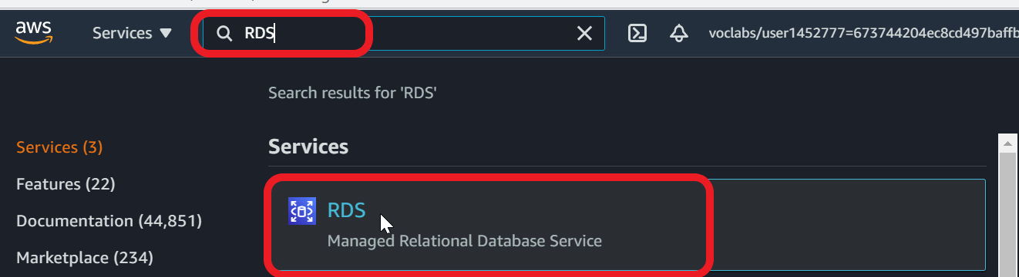

1. Select **Databases** in the navigation pane
2. **Create database**

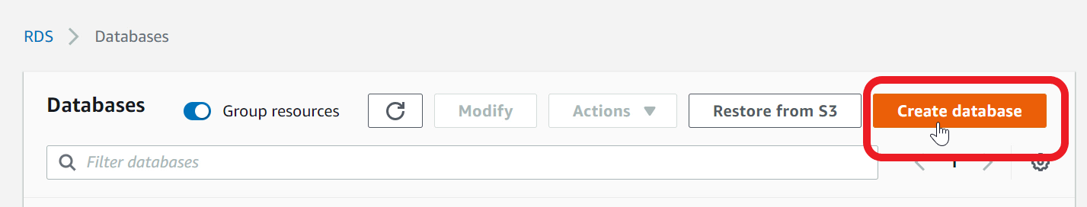

1. For **database creation method** - select **Standard Create**

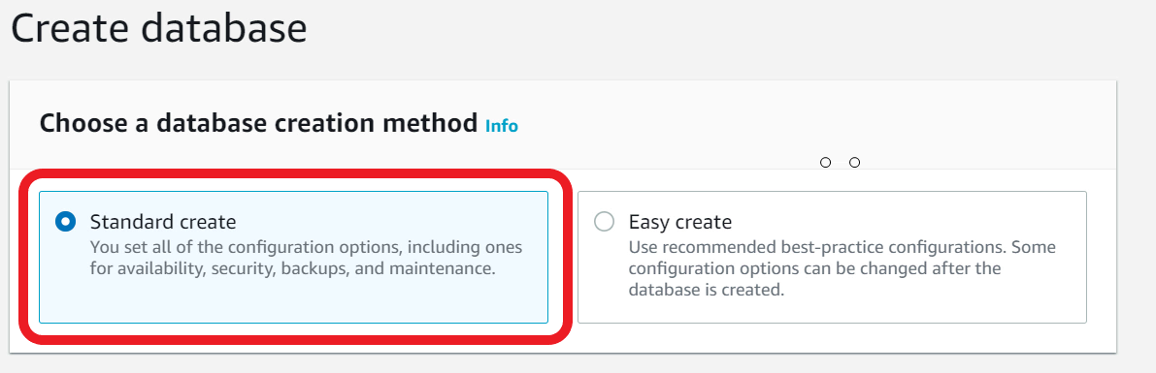

1. Under **Engine Type** - select **Amazon Aurora**

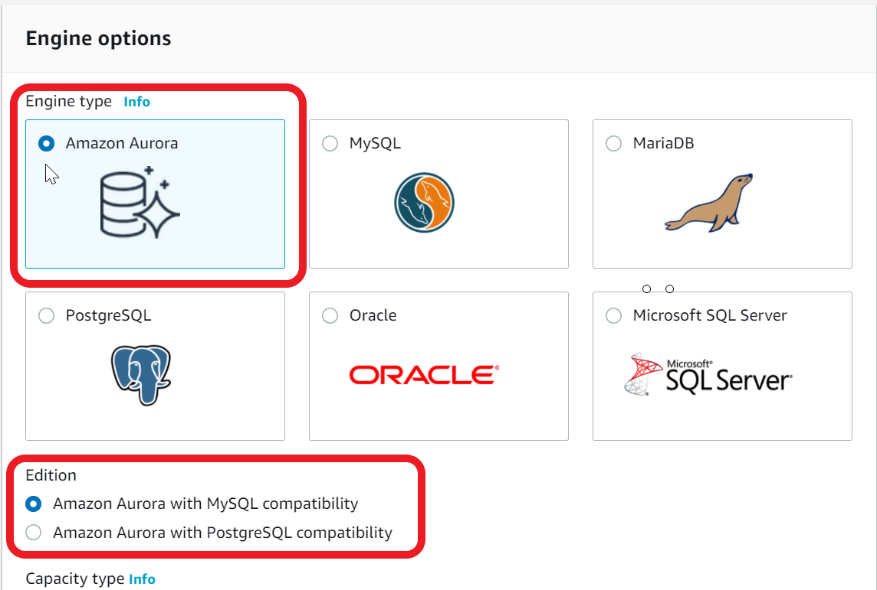

1. Edition - select**Amazon Aurora with MySQL Compatibility**
2. Capacity Type - choose **Provisioned**
3. Scroll to **Templates** section - select **Dev/Test**

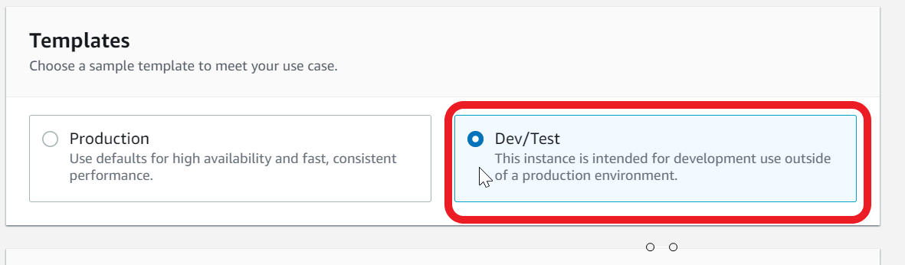

1. Under **Settings**, specify **DB Cluster Identifier** - type **demodatabase**

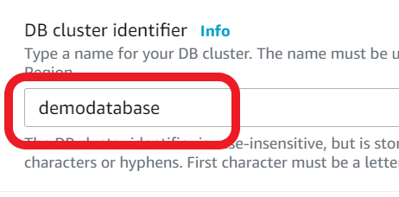

1. For **Master username** - type **admin**
2. For **Master password** - type **lab21Wow!**

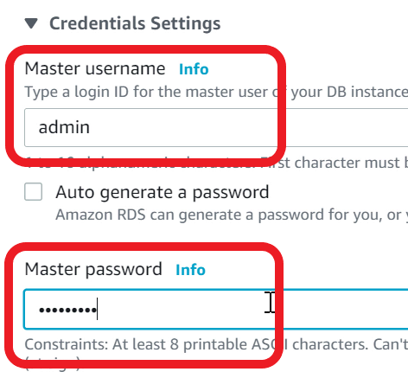

1. **Confirm password**
2. Under **DB Instance Class** - choose **Burstable classes**
3. Ensure **db.t3.small**is selected in the choice list

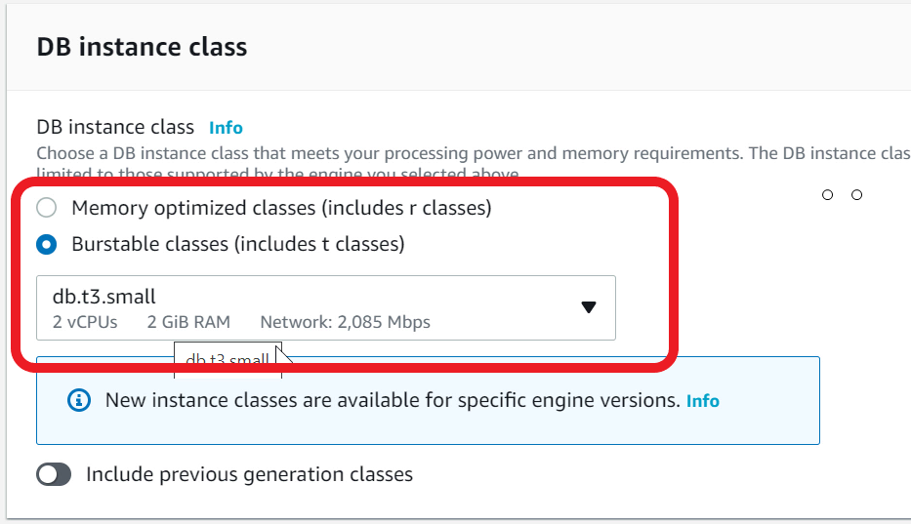

1. Under **Multi-AZ deployment** - select **Don't create an Aurora Replica**
2. Under **Connectivity** - ensure **Default VPC** is used

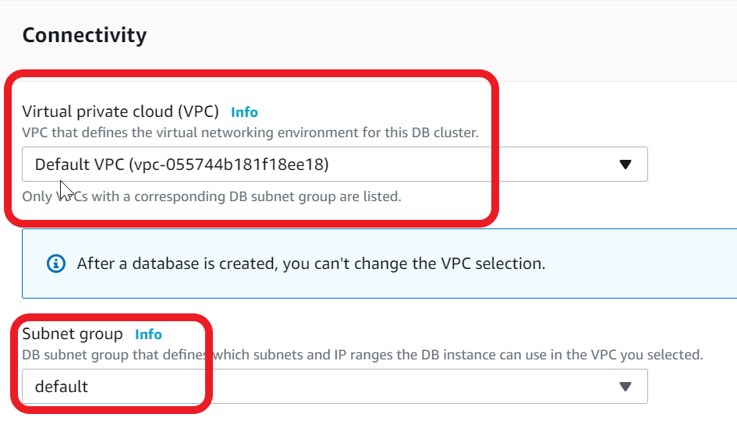

1. For **VPC security group -**select **Choose existing**
2. Ensure the **default** Security Group is attached

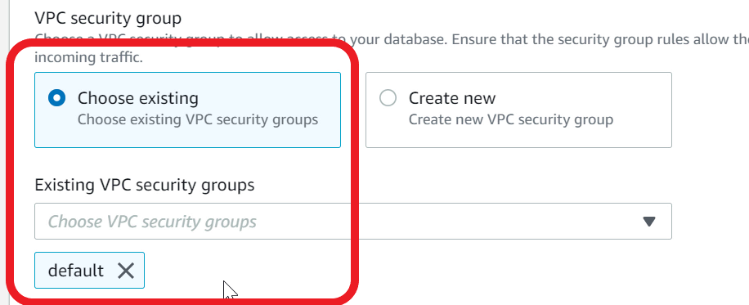

1. Expand **Additional Configuration**
2. For **Initial Database name** - type **productreview**

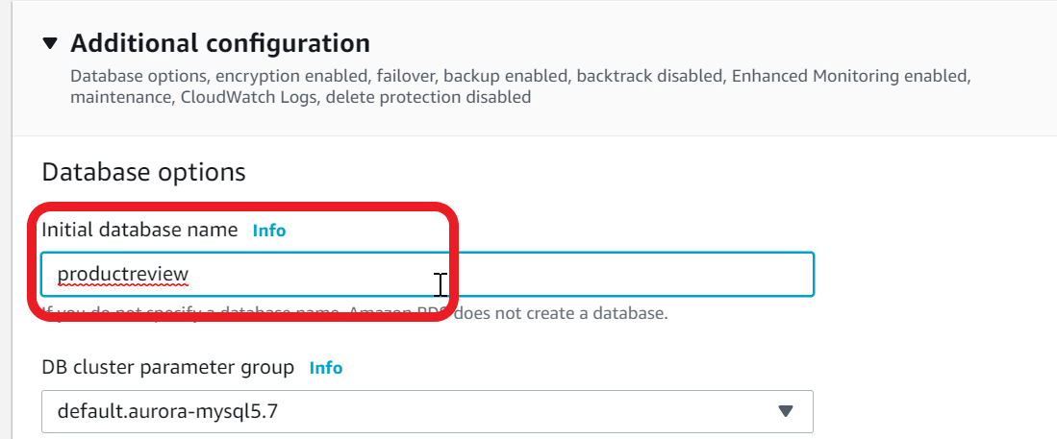

1. Scroll to bottom and **Create database**
2. Database instance creation will take 10-15 minutes
3. Wait until database **Status** changes to **Available**(you may have to refresh the page periodically)

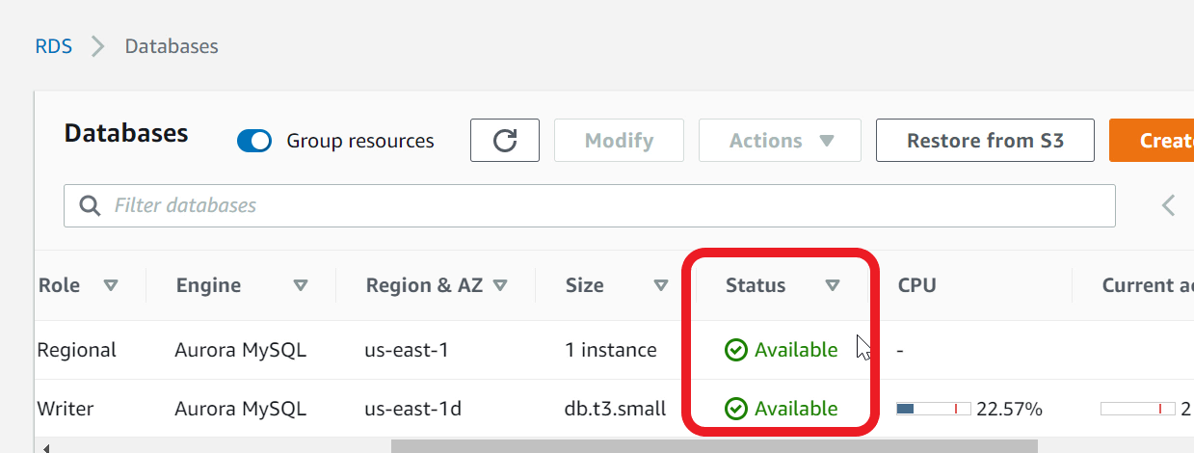

<https://docs.aws.amazon.com/AmazonRDS/latest/AuroraUserGuide/CHAP_GettingStartedAurora.CreatingConnecting.Aurora.html>

Configure Secrets Manager to store datsbase crendential

You will need to store the database **admin** user credentials in the **Secrets Manager**. The RDS Proxy that you will create later must use this secret to connect to the Aurora database.

1. Open **Secrets Manager** console

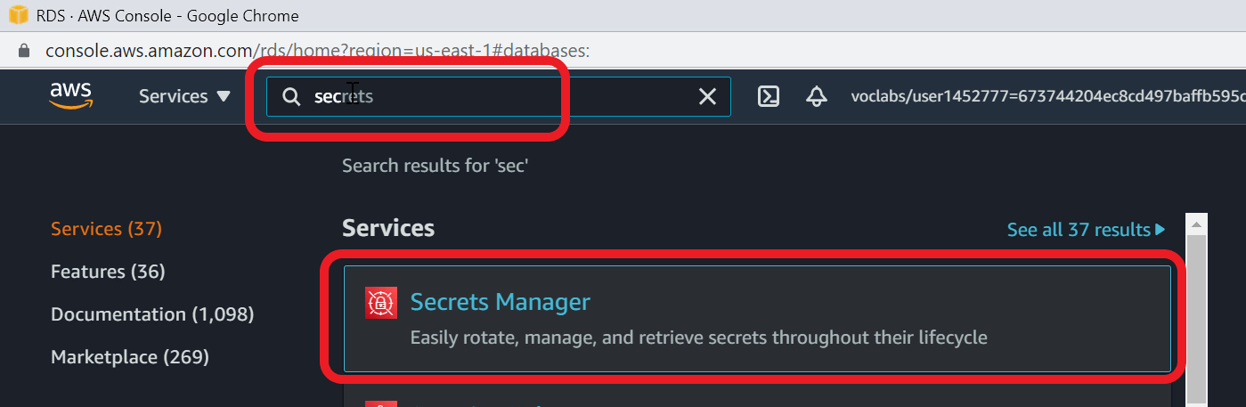

1. **Click on Store a new secret**

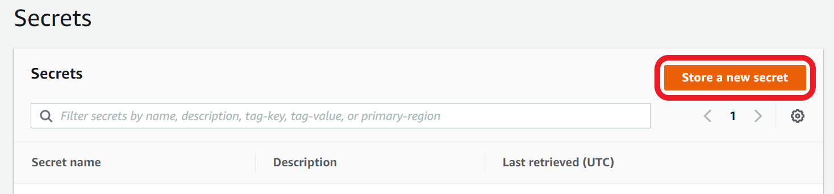

1. For **Secret type** - Select **Credentials for RDS database**

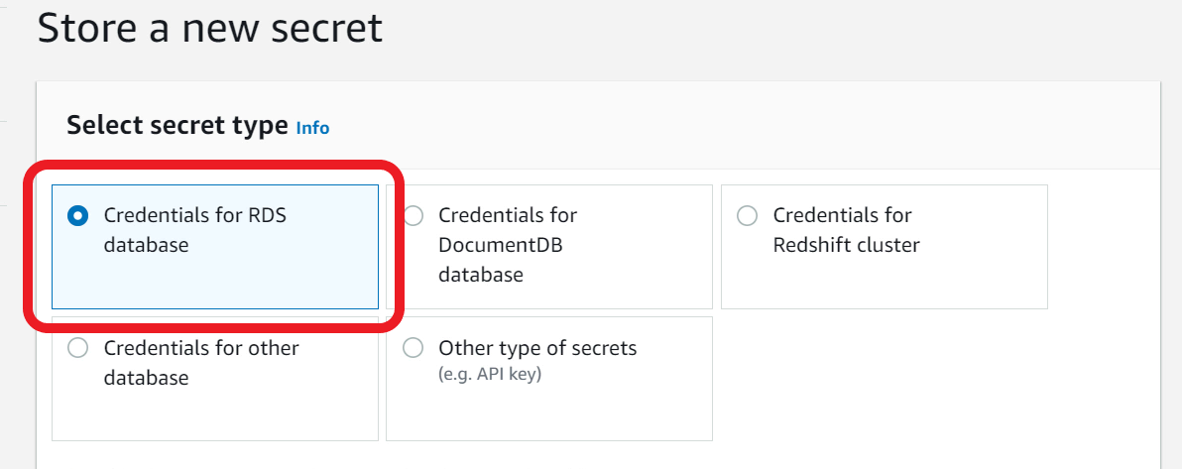

1. For User name - type **admin**
2. For Password - type **lab21Wow!**
3. Note: For production usage, you must create an application specific database user and not use admin
4. Scroll down to **Select which RDS database this secret will access**
5. Choose **demodatabase**

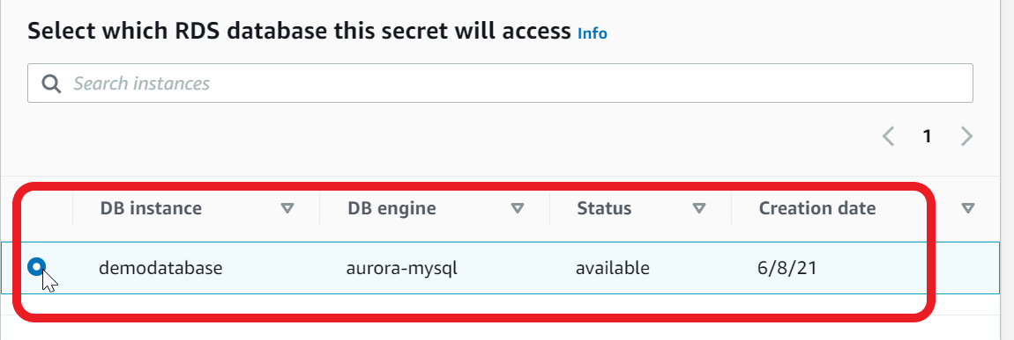

1. Go to **Next** page
2. For **Secret name** - type **productReview/demo/admin**

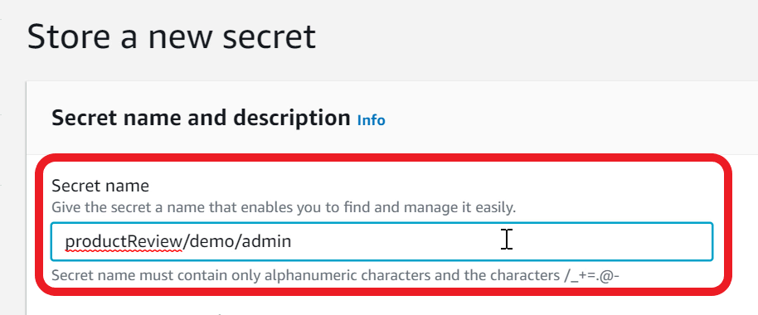

1. If you get an error that the secret name already exists or is scheduled for deletion, you can add a suffix to the new name such as **productReview/demo/admin01**. Make sure you use the new secret for subsequent steps
2. Continue to **next**page until you see the **review** page and **Store** the secret

Mark task as complete

Report issue

Launch RDS proxy in default VPC

You will need to launch an **RDS Proxy** for your Aurora-MySQL compatible database instance. Name the proxy as **productreviewproxy**.

Deploy the RDS Proxy in the **default VPC** and attach the **default securitygroup**. The RDS Proxy must require **IAM authentication** for applications to request connection. For database credentials, you must configure the proxy to use the **secret** that you created previously. Ensure proxy supports **Transport Layer Security**.

1. From **RDS Console**, Select **Proxies** in the navigation pane
2. Click on **Create Proxy**

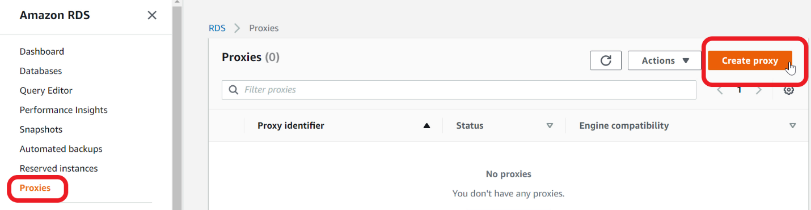

1. For **Proxy identifier** - type **productreviewproxy**
2. Ensure **Engine compatibility** is set to **MySQL**
3. **Select** the **Require Transport Layer Security** check box

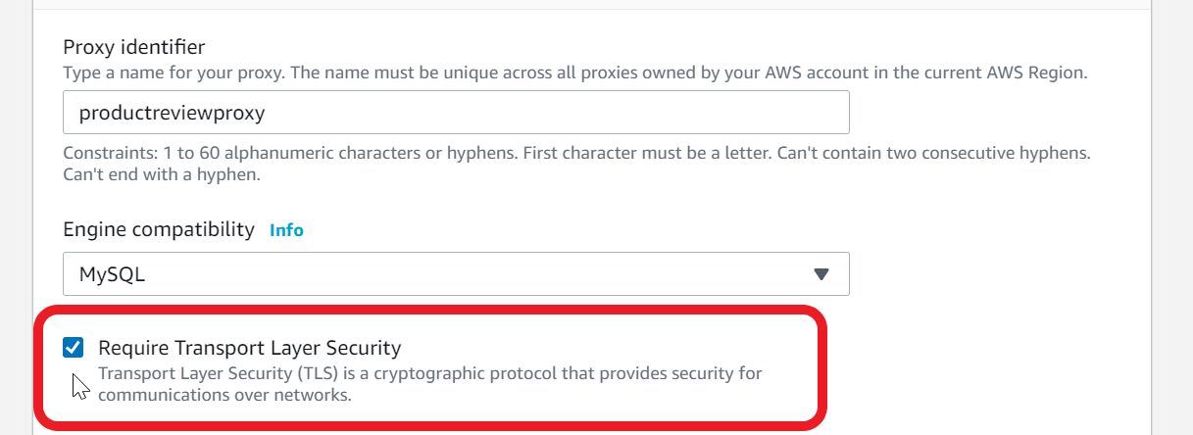

1. Scroll down to Target group configuration
2. For **Database** - select **demodatabase**
3. Goto **Connectivity** section
4. Under **Secrets Manager secrets** - select **productReview/demo/admin** that you created previously
5. For **IAM role** - select **Create IAM role**

Note - This will automatically create a new role with required permissions to access secrets manager

1. For **IAM Authentication** - select **Required**

Note - With this option, application can get connections from RDS Proxy using IAM roles - recommended and secure

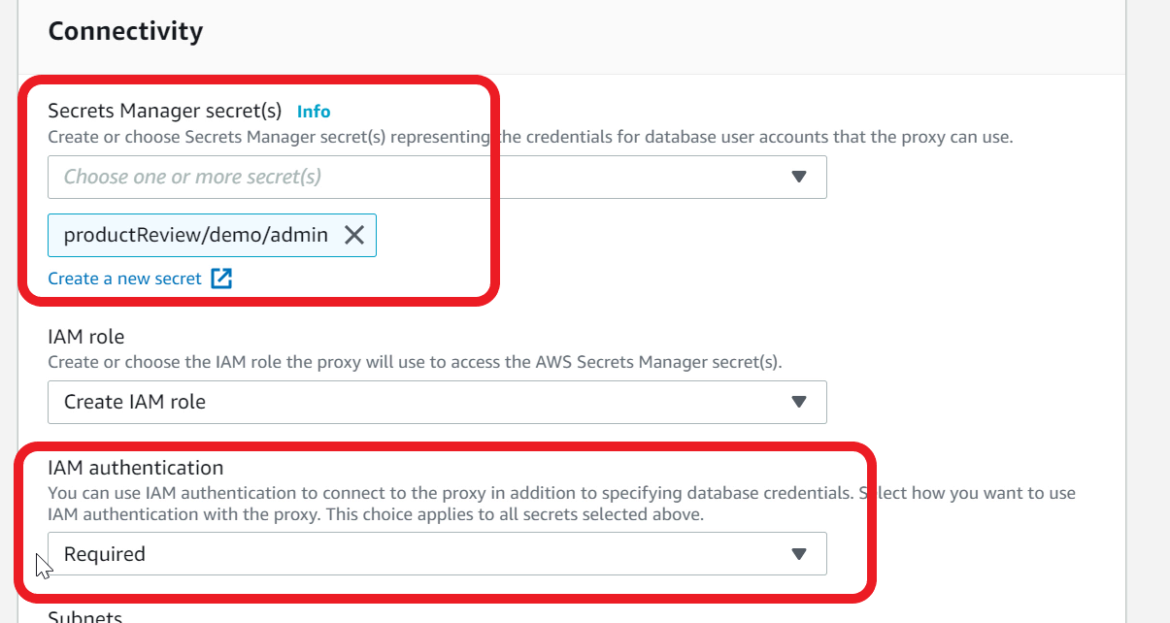

1. For **Subnets** - ensure all the subnets in the default VPC are selected. Note - the **subnet-ids** will be **different**.

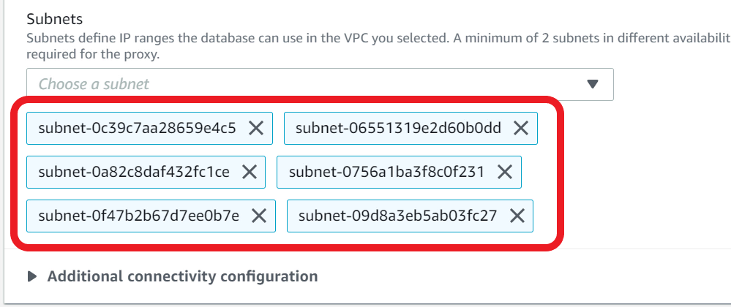

1. Expand **Additional connectivity configuration**
2. Ensure for **VPC Security Group** - **Choose existing**is selected
3. Ensure **default** security group is selected and shown in the **Existing Security Groups**

Note - Since Aurora database and RDS Proxy are in the same **default** Security Group, they can communicate with each other

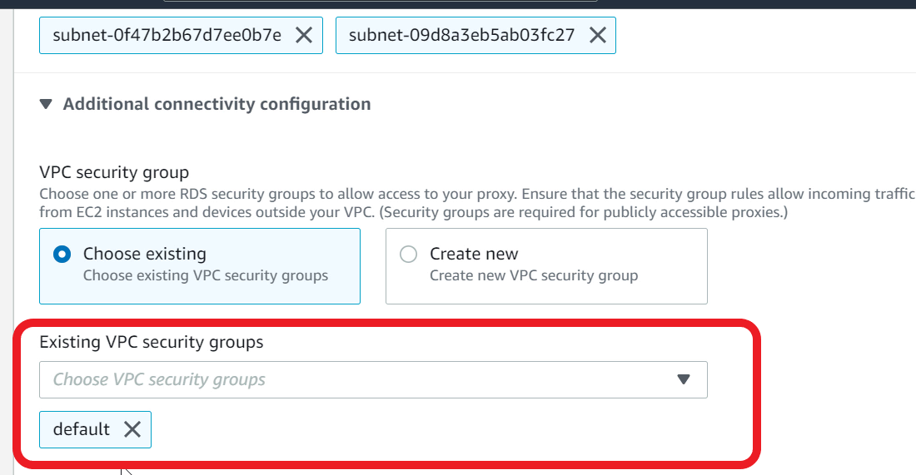

1. Click on **Create Proxy**
2. RDS Proxy creation should take **10-15 minutes**. Wait until the status changes to **Available**(you may have to refresh the page periodically)

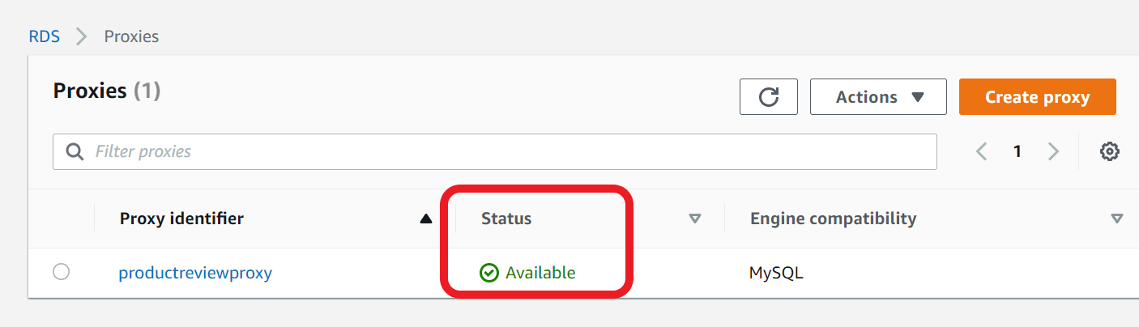

<https://aws.amazon.com/rds/proxy/>

Create a Lamba Layer for python pymysql library and IAM role for Lambda function

PyMySQL is a Python library that you can use in your Python code to connect to an Aurora-MySQL compatible database and RDS Proxy. PyMySQL is not part of the Lambda Python runtime, so you need to add this library as a Lambda Layer. Once the Layer is created, you can add the Layer to many Lambda functions. You would also need to create an IAM Role so that your lambda function can log to CloudWatch log and run inside a VPC.

1. Download the **layer-pymysql.zip** file available in the Resources folder under 'Assets'.
2. S**ave** the file to your local computer, and we need this zip to create a Lambda layer
3. Open **Lambda** Console

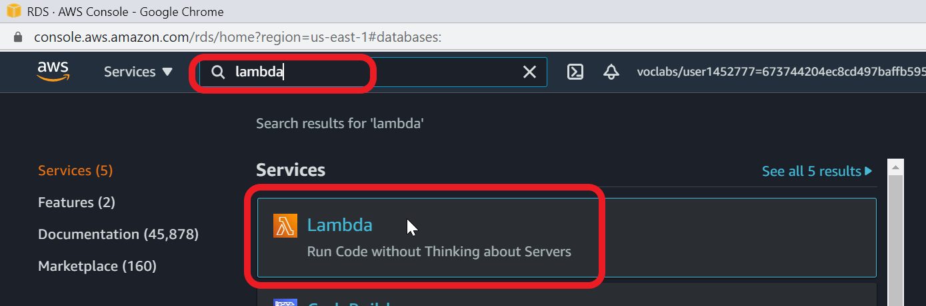

1. Choose **Layers** from navigation pane
2. Click **Create layer**

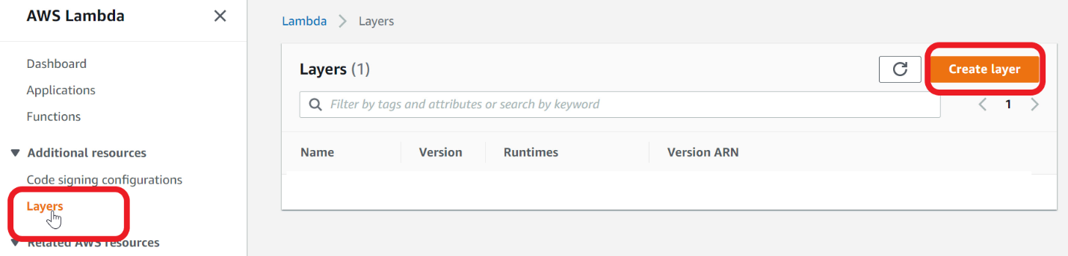

1. For **Name** - type **layer-pymysql**
2. Provide a **Description** - type **pymysql python library**
3. Select **Upload a zip file**
4. Choose the **layer_pymysql.zip** file that you saved earlier on your local computer
5. For **Compatible runtimes** - select **Python 3.7** and **Python 3.8**

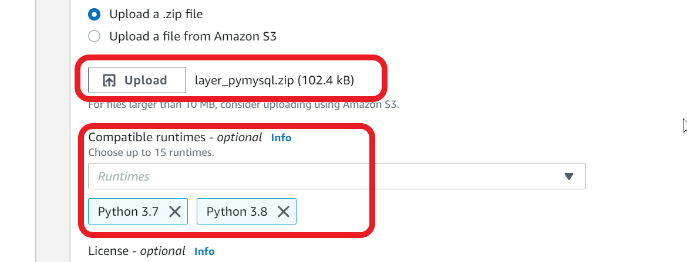

1. Click **Create** Layer
2. Lambda Layer is ready to use

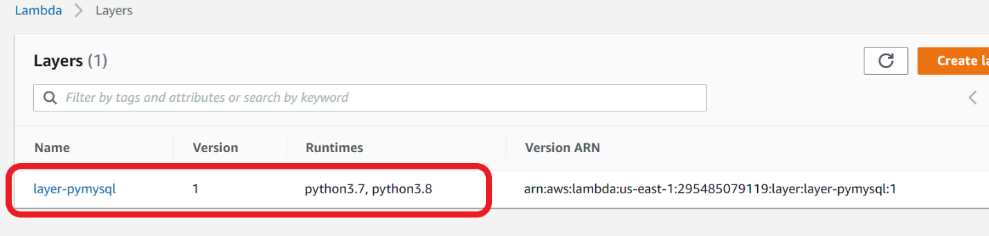

1. You now need to create an IAM Role for the Lambda function
2. Open **IAM** Console

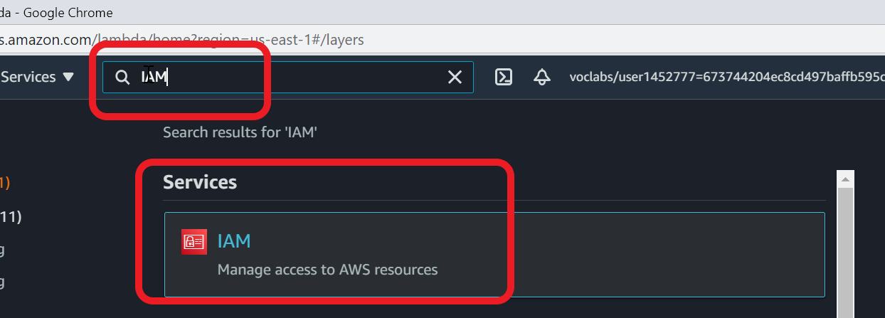

1. Select **Roles** from Navigation pane
2. Click **Create role**

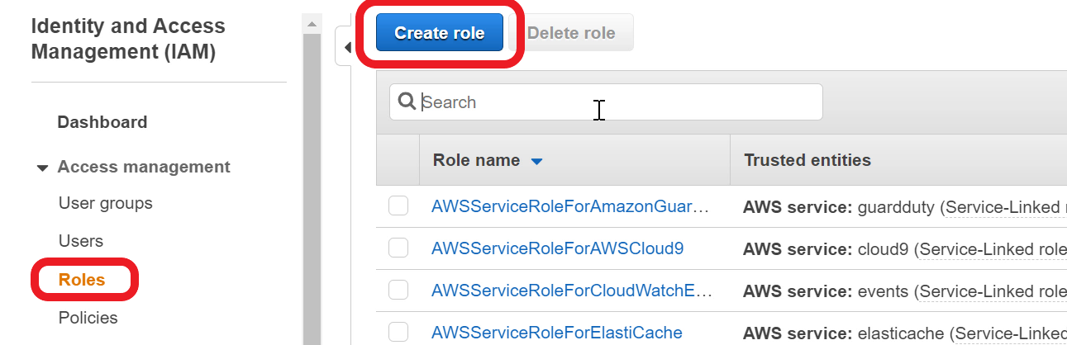

1. Ensure **AWS Service** is selected. Under **Choose a use case** - select **Lambda**

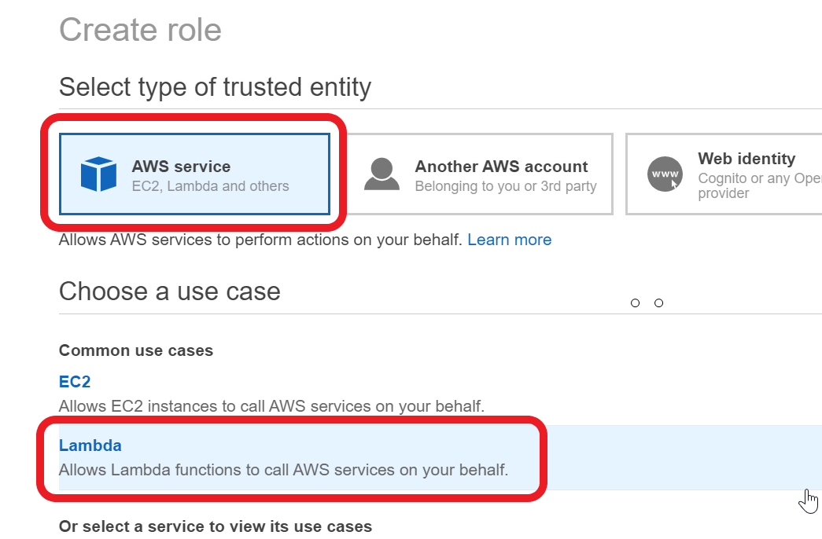

1. Go to **Next: Permissions** page
2. In the **Filter** text box - type **AWSLambdaBasicExecutionRole**
3. Select the **AWSLambdaBasicExecutionRole.** This grants permission to log to CloudWatch Log

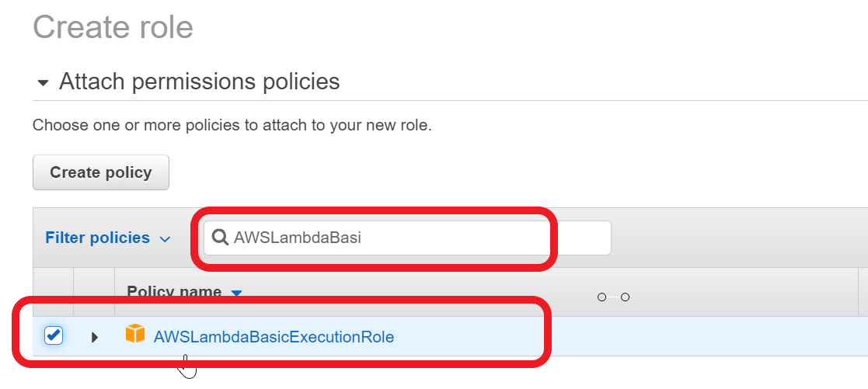

1. In the **Filter** text box, now type **AWSLambdaVPCAccessExecutionRole.**
2. Select **AWSLambdaVPCAccessExecutionRole.**This policy grants permission to create a network interface inside a VPC. This is needed as the health check lambda function will run in the default VPC

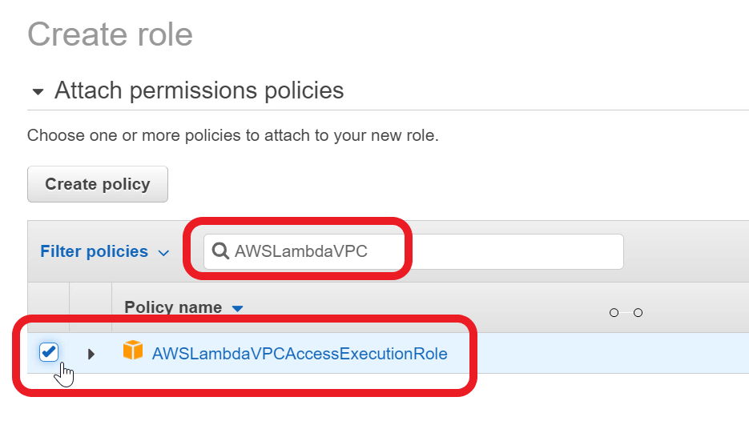

1. Go to **Next**page. Continue to **Next: Review**page
2. For **Role name** - type **lambda_rds_vpc**
3. For **Role description** - type **allow lambda to log, and run inside VPC**

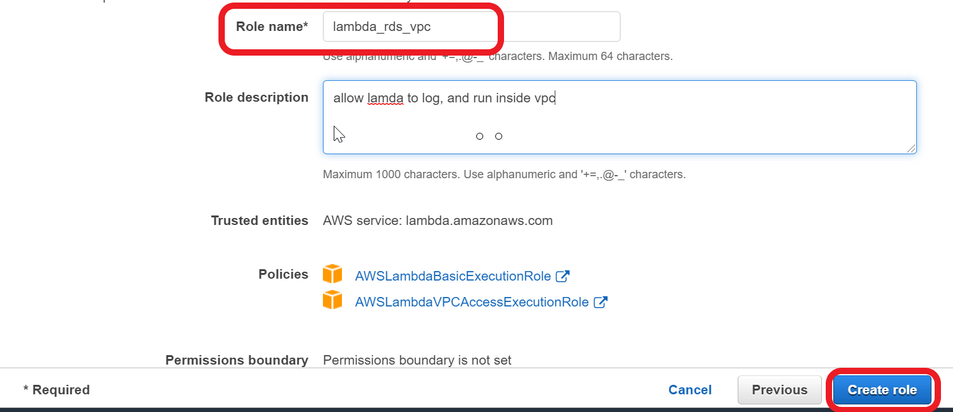

1. Click **Create role**
2. IAM role is now ready

Ref layer_pymysql.zip doc

<https://docs.aws.amazon.com/lambda/latest/dg/configuration-layers.html>

Create a health check Lambda function to test database connectivity,create table, and populate data

You now need to build a health check Lambda function to **test** database connectivity, create the product and review tables, and populate a couple of products and reviews. The health check function would help you troubleshoot and fix connectivity issues. This Lambda function needs to use the **RDS Proxy endpoint** to acquire a database connection. Deploy the Lambda function in the **default VPC** and attach the **default security group** to the function.

1. Open **Lambda** console
2. Click on **Functions** in the navigation pane
3. Click **Create function**
4. Choose - **Author from scratch**
5. For **Function name** - type **product_review_healthcheck**
6. For **Runtime** - select **Python 3.8**

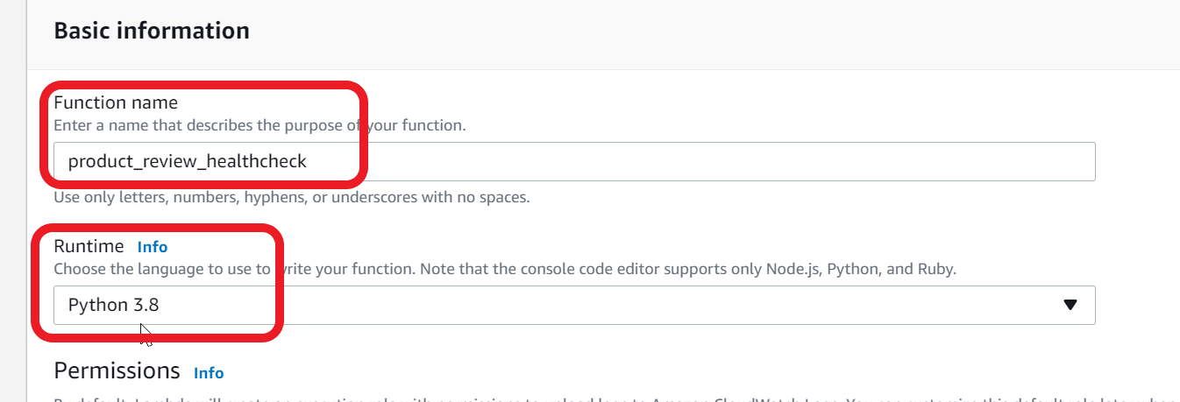

1. Under **Permissions** - expand **Change default execution role**
2. Select - **Use an existing role**
3. In the **Existing role** choice list - select **lambda_rds_vpc** role that you created earlier

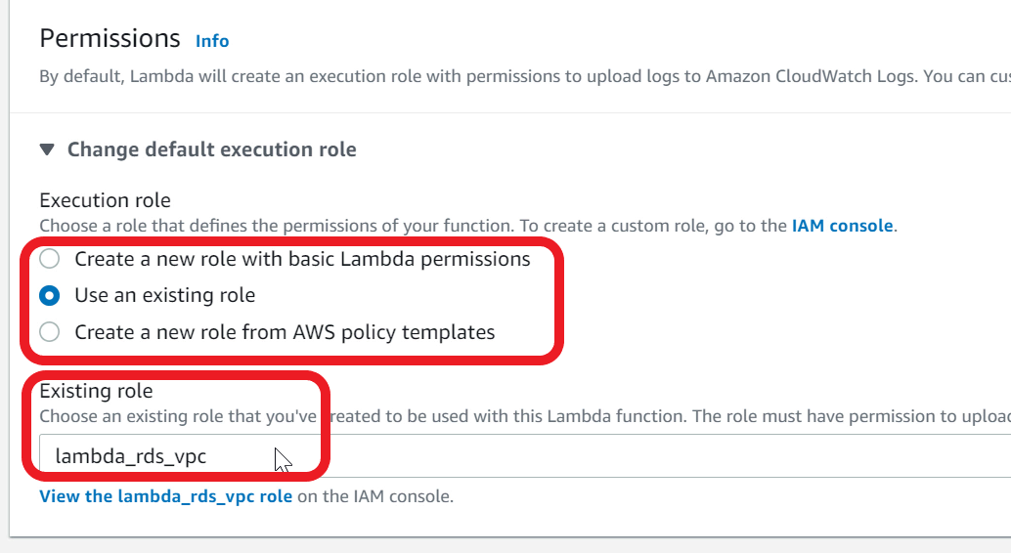

1. Expand **Advanced settings**
2. For **VPC** - Choose **Default**VPC. Note - VPC-id will be different for your console.

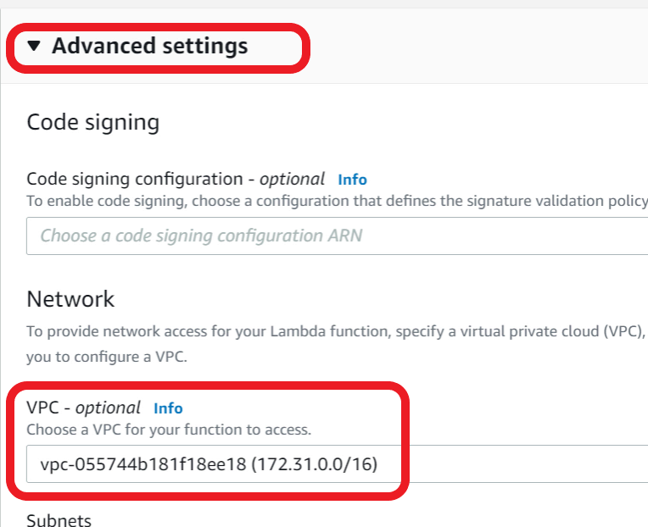

1. For **Subnets** - Choose all available subnets

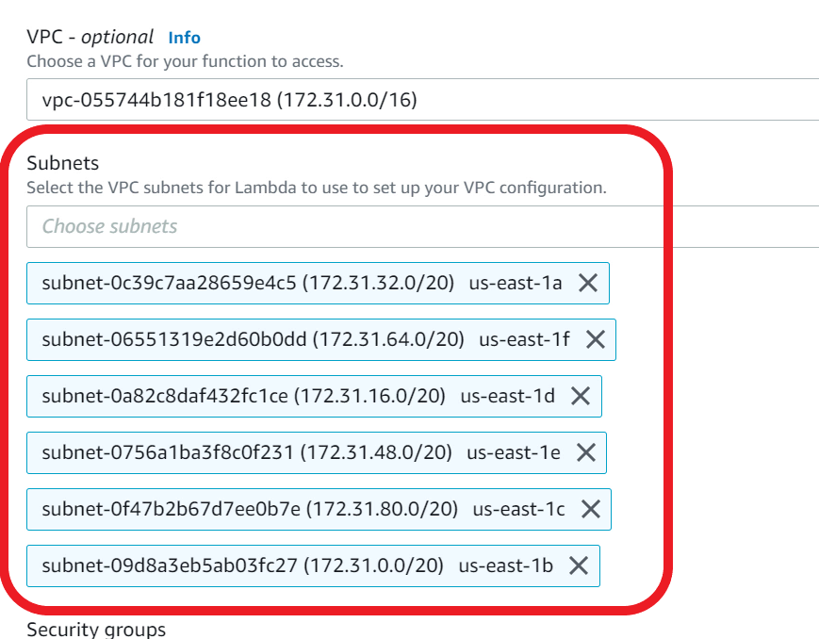

1. For **Security Group** - choose **default VPC security group**

This security group allows lambda function to connect to RDS Proxy as both are attached to default security group

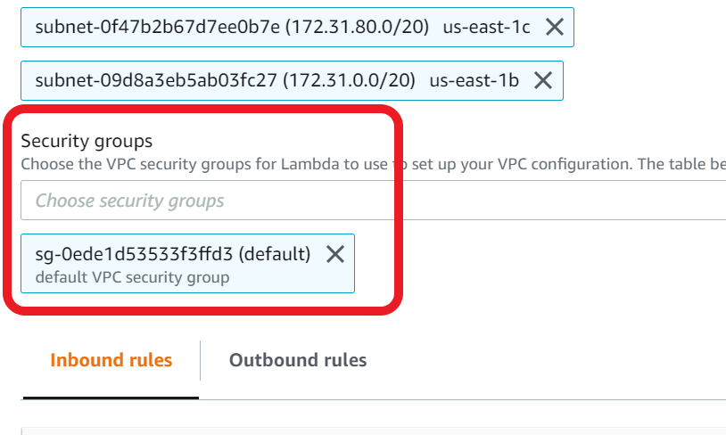

1. Click **Create function**
2. Lambda will take a **few minutes** to create the function and attach to VPC. You may notice the **screen refreshing** on its own when it is creating the function. Give it a couple of minutes for the function to be created
3. Download the **healthCheckLambda.zip** file available in the assets.
4. **Save** the file to your local computer. This file has the code for health check function
5. In the Lambda console, scroll down to the **Code** section

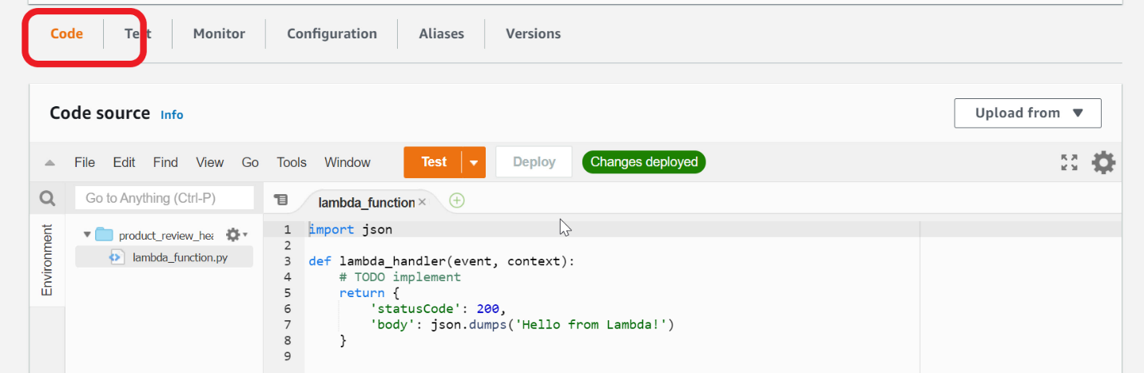

1. In the **Upload from** choice list, select **zip file**

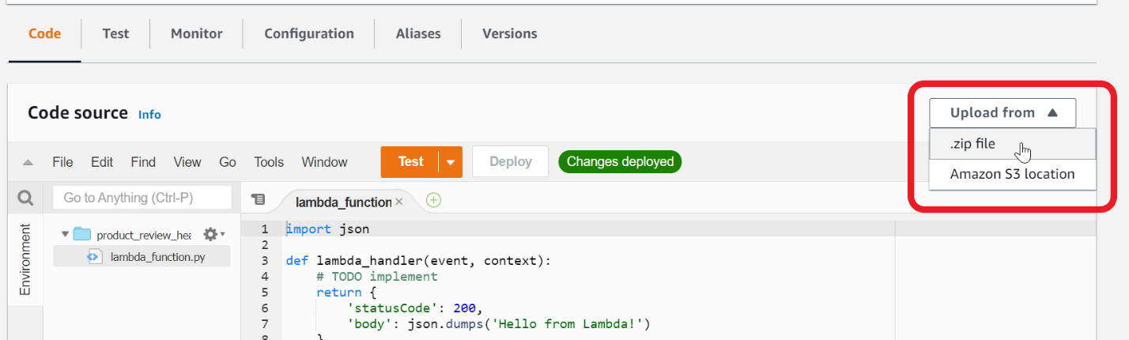

1. Choose the **healthCheckLambda.zip** file that you saved earlier on your local computer

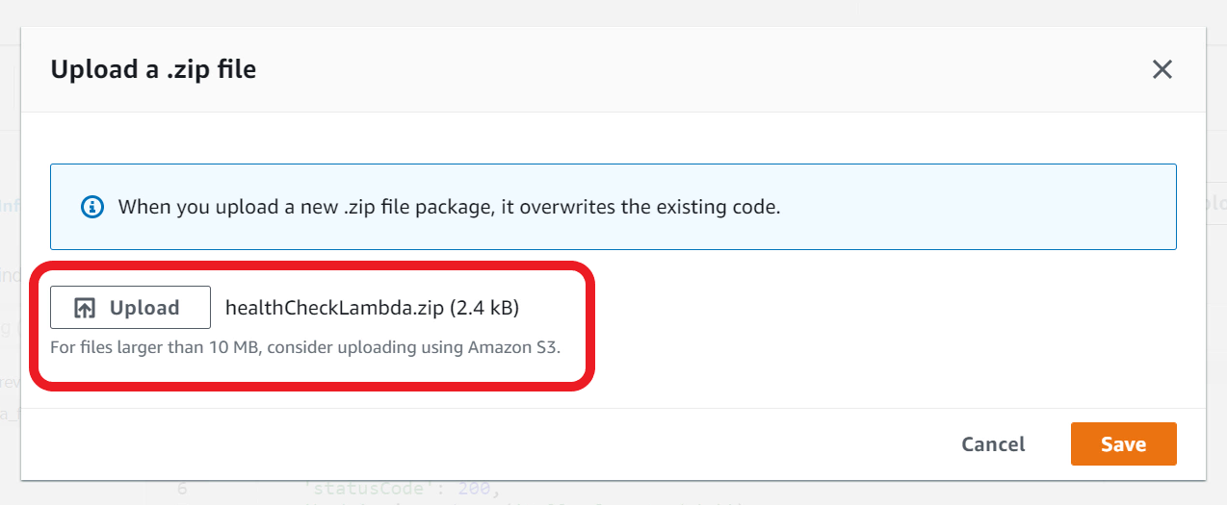

1. Click **Save**. You can now view the health check function implementation.

Ref healthcheckLamda.zip doc

<https://pypi.org/project/PyMySQL/>

Integrate database Proxy and Lambda layer with health check lambda function

Ensure your function code uses Database Proxy and Lambda Layer.

1. In the **product_review_healthcheck**Lambda function, scroll down to the **code section**
2. Update the **proxyEndPoint** variable value to point to your **database proxy endpoint**

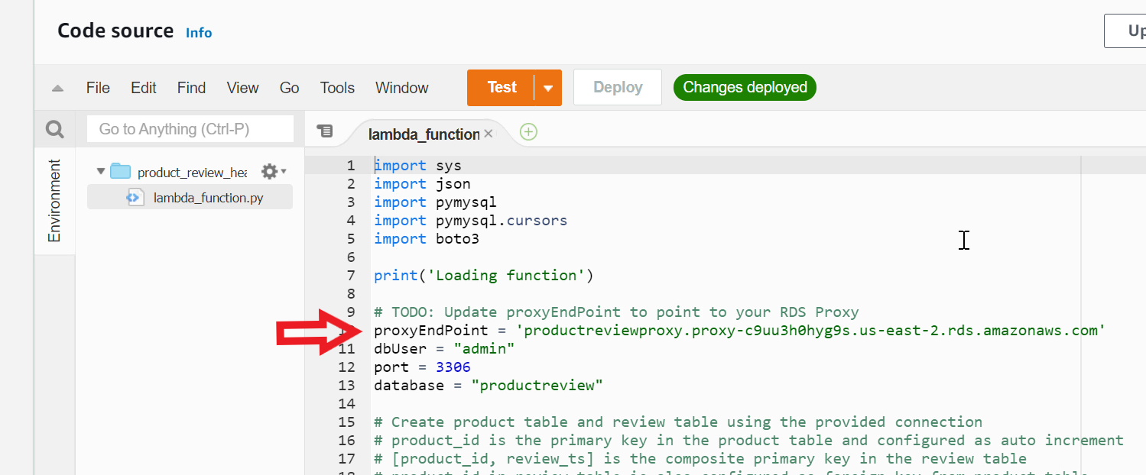

1. To find the Proxy endpoint, open **RDS** Console
2. Choose **Proxies** from the navigation pane. Select **productreviewproxy**

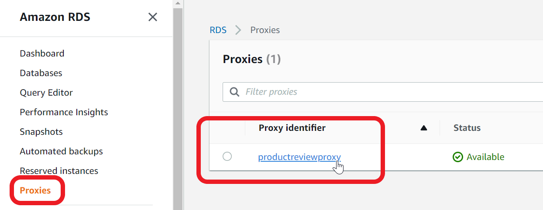

1. Scroll down to **Proxy endpoints**. There are two endpoints. The first endpoint is for reading and writing to the database. The second endpoint is for read-only queries. Copy the **first endpoint** (read-write)

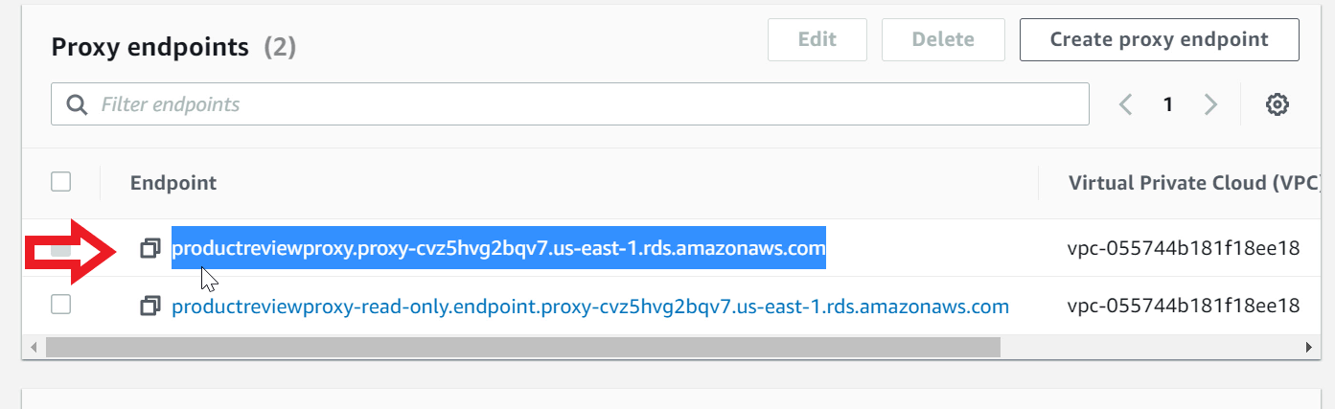

1. Go back to **Lambda** console, open **product_review_healthcheck** function
2. Update the **proxyEndpoint**variable value

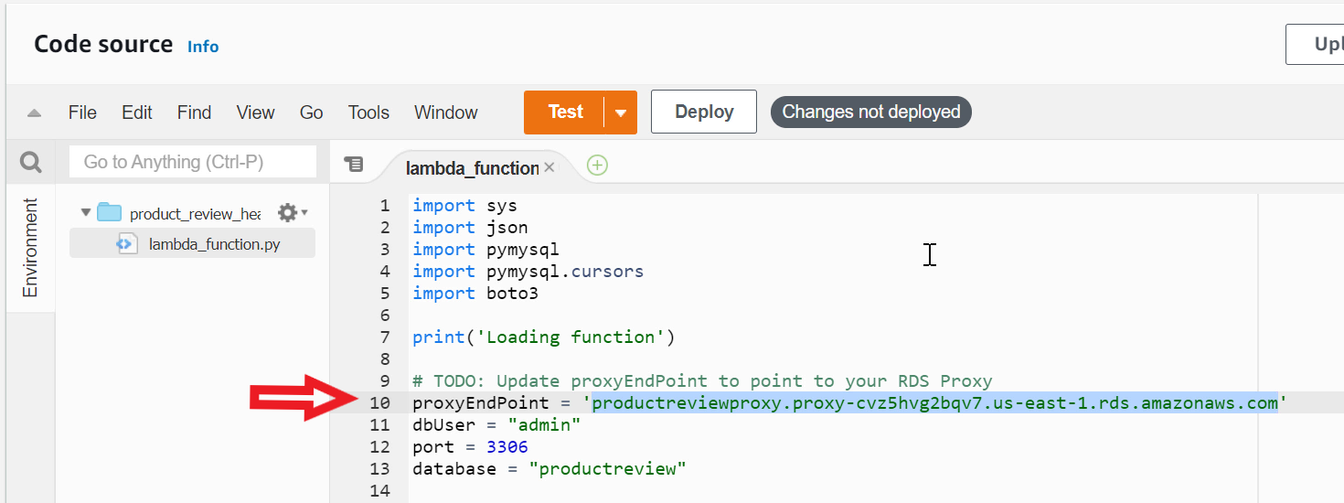

1. Click **Deploy** to deploy the updated code

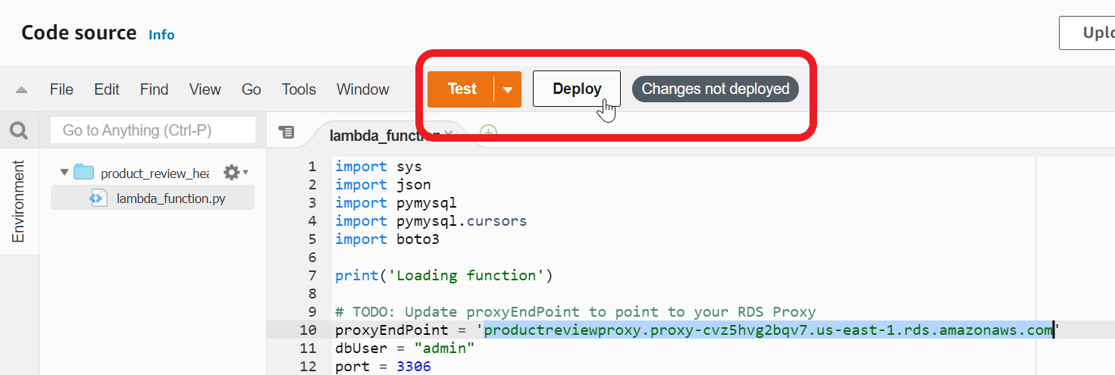

1. Now scroll down to the bottom of the page to **Layers** section
2. Click **Add a layer**

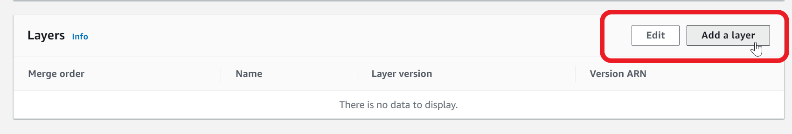

1. Select **Custom Layers**
2. In the **Custom layers** drop down - select **layer-pymysql**
3. In the **Version** drop down - select **1**

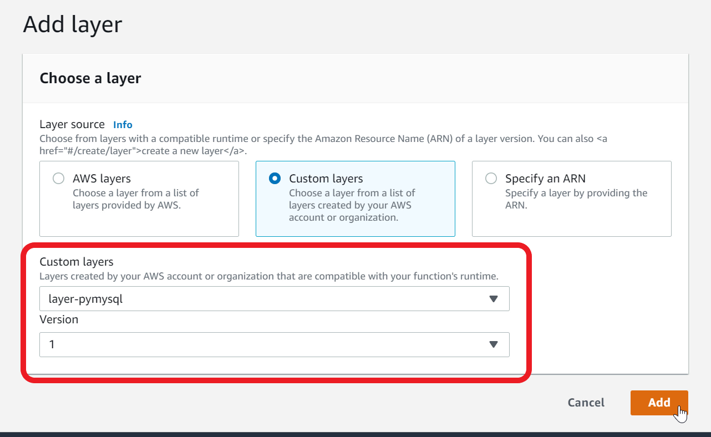

1. Click **Add**
2. You now need to add **RDS Proxy** to Lambda Function
3. Select **Configuration** tab

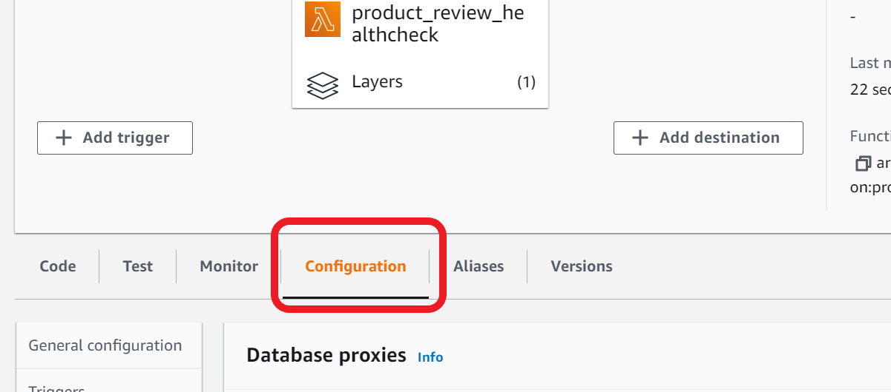

1. Select **Database proxies** in the navigation pane

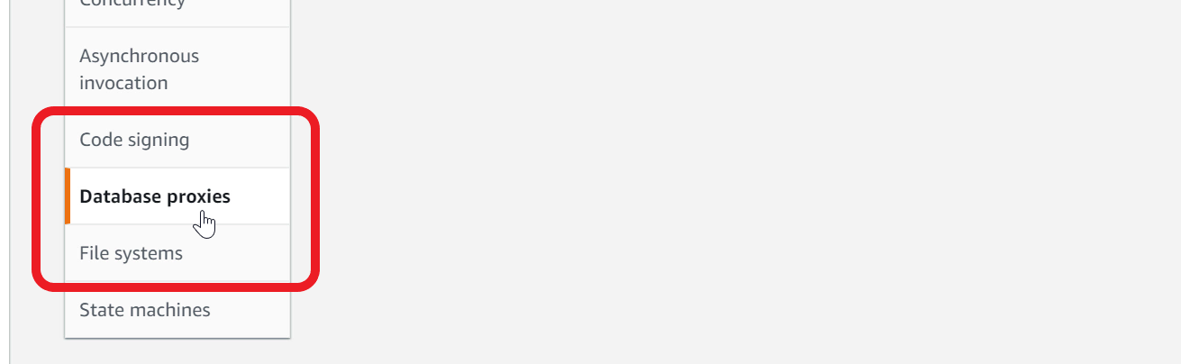

1. Click **Add database proxy**
2. **Choose an existing proxy**
3. Select - **productreviewproxy** from the drop down

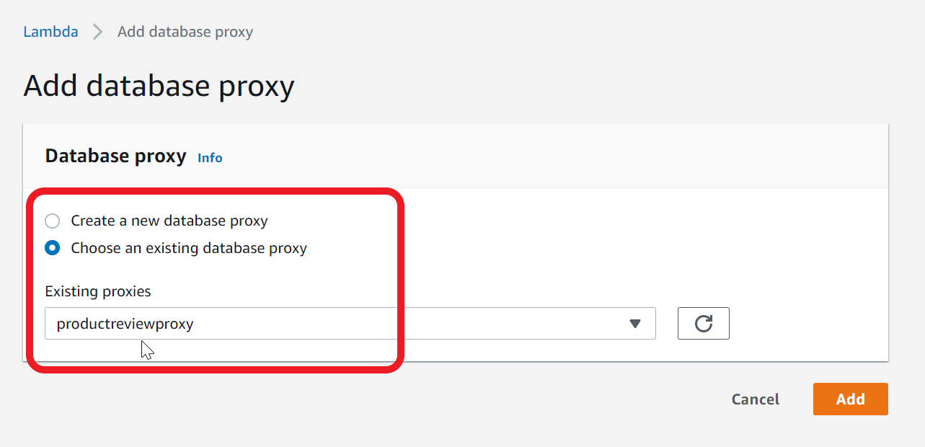

1. Click **Add.**This will add necessary permissions to your Lambda IAM Role to call database proxy and acquire connection
2. Lambda function is now ready to test

Invoke health check function

Configure a test event and invoke the product review health check function from Lambda console. Ensure product and review tables are created with sample data.

1. Go to the **code** section of the **product_review_healthcheck**Lambda function
2. In the **Test** dropdown, choose **Configure a test event**. You need to create a test event to pass to the lambda function

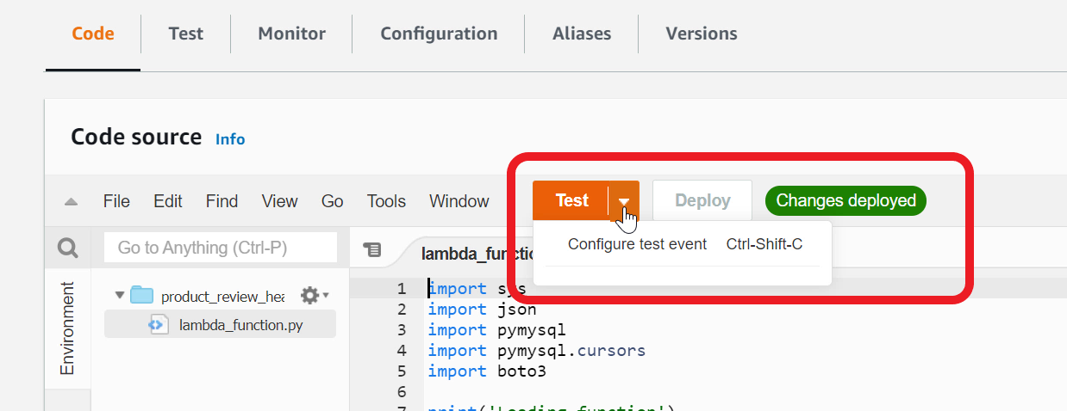

1. This function does not expect any particular event data - so a hello world event is good enough. In the **Event template** - make sure **hello-world** is selected
2. For **Event name** - type **healthCheckTest**

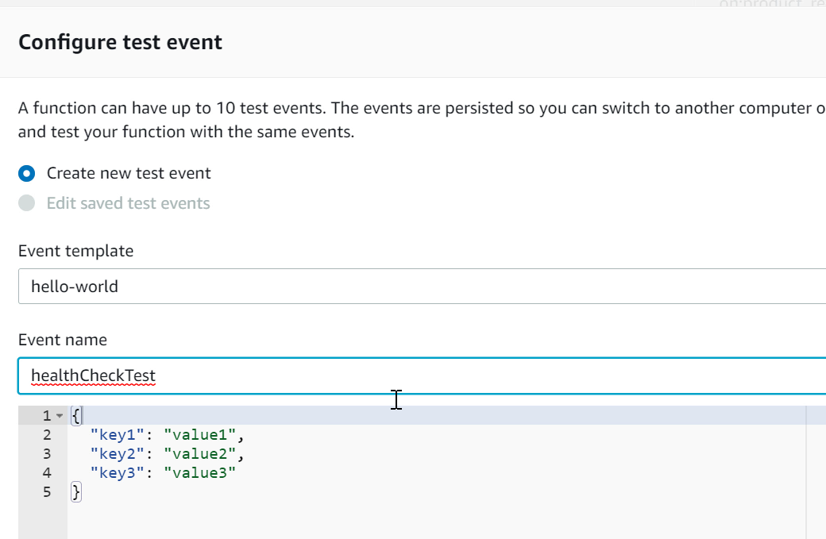

1. **Create** the test event
2. Click on the **Test** button (not the drop down arrow)**.**When you call the function for the first time, it will connect the database using RDS proxy, create the product and review tables in the **productreview** database, insert rows in product and review tables.

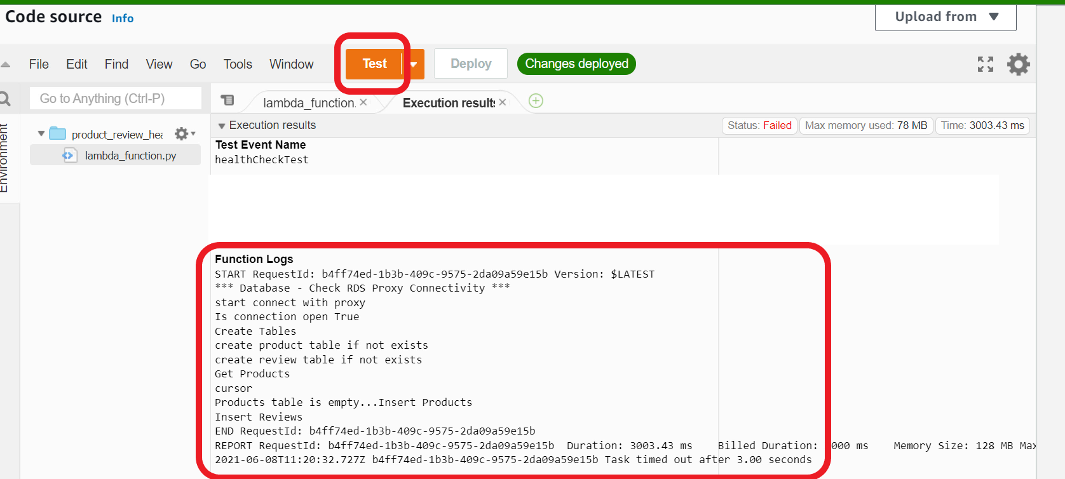

1. Click on **Test**again. This time, the function will read the rows and display **products**

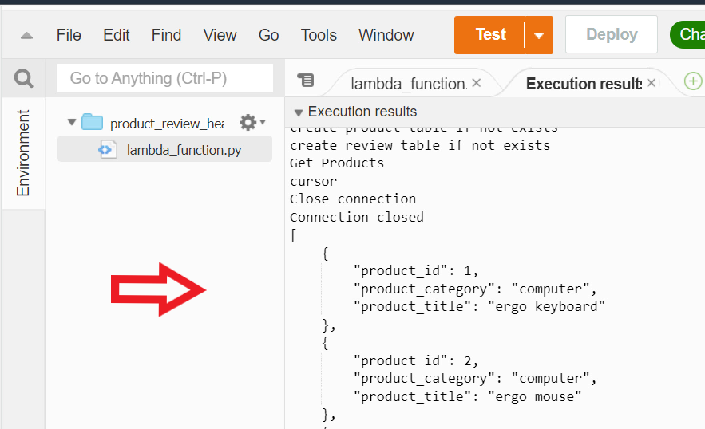

1. You can click on **Test** as many times as you like. You have now successfully completed a health check and created required tables and initial data

Mark task as complete

Report issue

Implement CRUD backend functionality

Create a new Lambda function **product_review_rds** and implement the backend functionality to manage products and reviews. The Lambda function must execute appropriate Create-Read-Update-Delete (CRUD) logic for the RESTful API that you designed earlier. This Lambda function needs to use the **RDS Proxy endpoint** to acquire a database connection. Deploy the Lambda function in the **default VPC** and attach the **default security group** to the function

1. Open **Lambda** console
2. Click on **Functions** in the navigation pane
3. Click **Create function**
4. Choose - **Author from scratch**
5. For **Function name** - type **product_review_rds**
6. For **Runtime** - select **Python 3.8**
7. Under **Permissions** - expand **Change default execution role**
8. Select - **Use an existing role**
9. In the **Existing role** choice list - select **lambda_rds_vpc** role that you created earlier

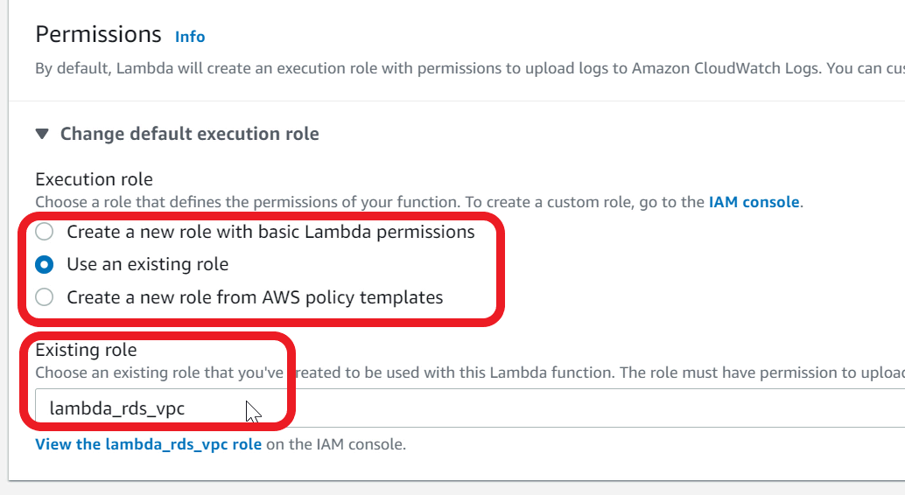

1. Expand **Advanced settings**
2. For **VPC** - Choose **Default**VPC

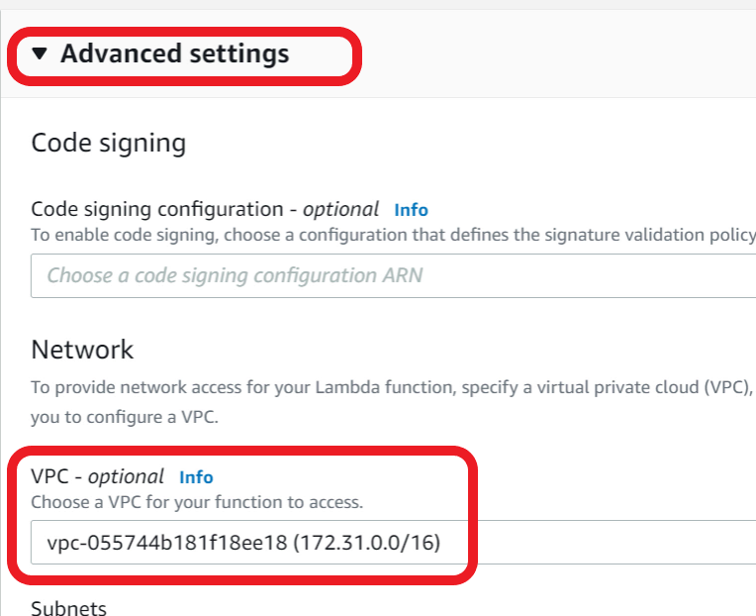

1. For **Subnets** - Choose all available subnets

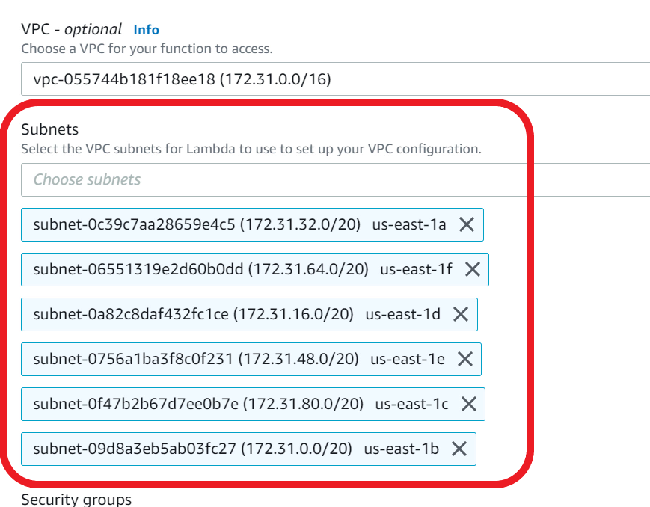

1. For **Security Group** - choose **default VPC security group**

This security group allows lambda function to connect to RDS Proxy as both are attached to default security group

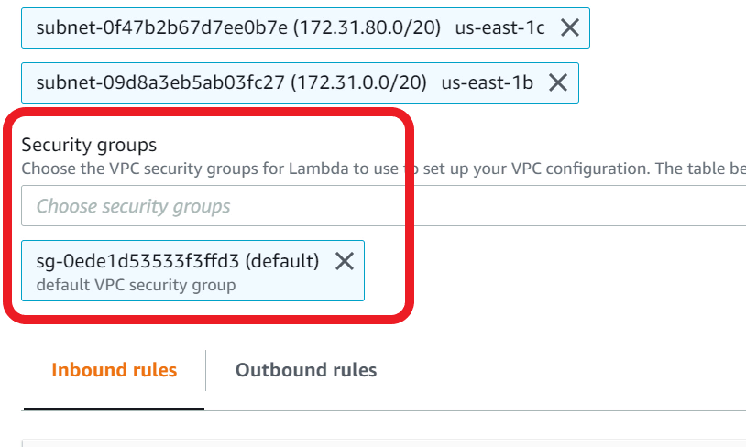

1. Click **Create function**
2. Lambda will take a **few minutes** to create the function and attach to VPC. You may notice the **screen refreshing** on its own when it is creating the function. Give it a couple of minutes for the function to be created
3. Download the **productReviewLambda.zip** file available in the assets.
4. **Save** the file to your local computer. This file has the code for function
5. In the Lambda console, scroll down to the **Code** section
6. In the **Upload from** choice list, select **zip file**

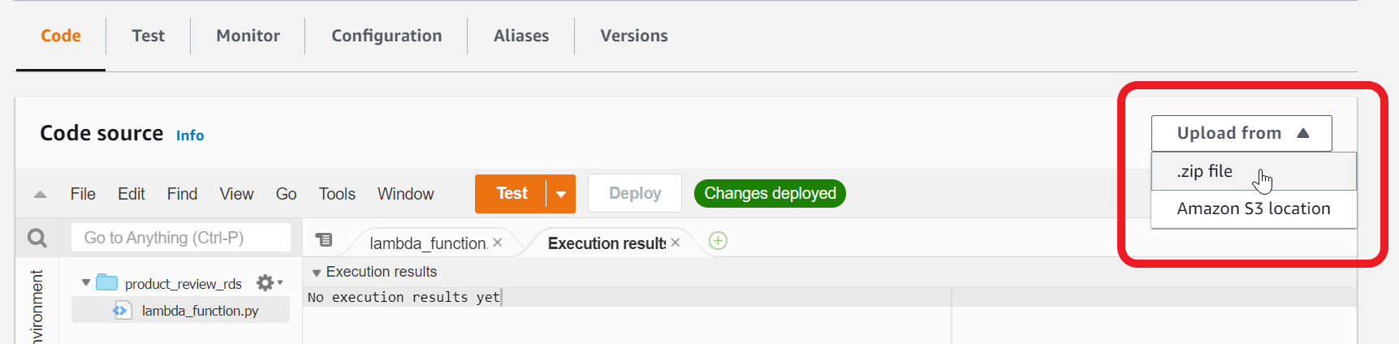

1. Choose the **productReviewLambda.zip** file that you saved earlier on your local computer

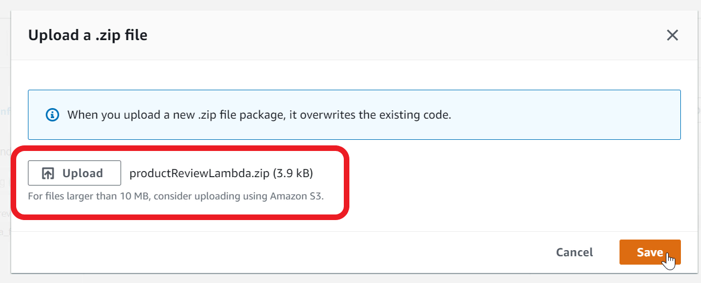

1. Click **Save**. You can now view the backend implementation for product-review CRUD

Ref productreviewLamda.zip

Integrate Database proxy and Lambda layer with the product review function

Ensure **product_review_rds**function uses Database Proxy and Lambda Layer.

1. In the **product_review_rds**Lambda function, scroll down to the **code section**
2. Update the **proxyEndPoint** variable value to point to your **database proxy endpoint.**You can copy the proxyEndpoint value from the health check Lambda function that you created earlier

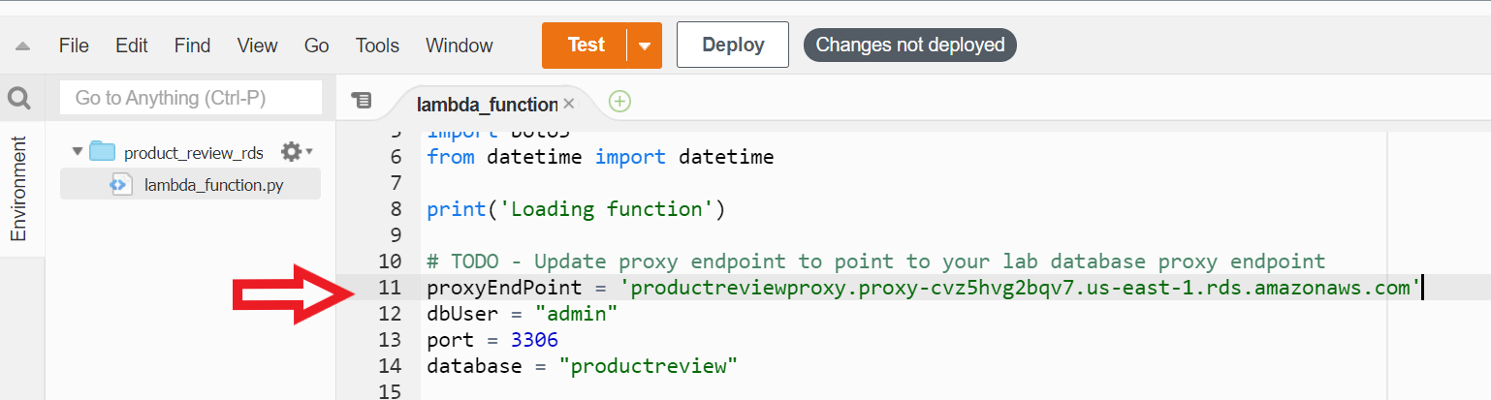

1. Click **Deploy** to deploy the updated code

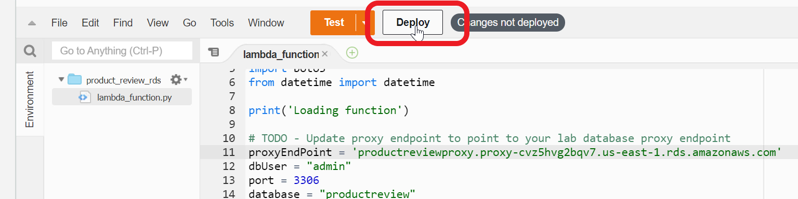

1. Now scroll down to the bottom of the page to **Layers** section
2. Click **Add a layer**



1. Select **Custom Layers**
2. In the **Custom layers** drop down - select **layer-pymysql**
3. In the **Version** drop down - select **1**

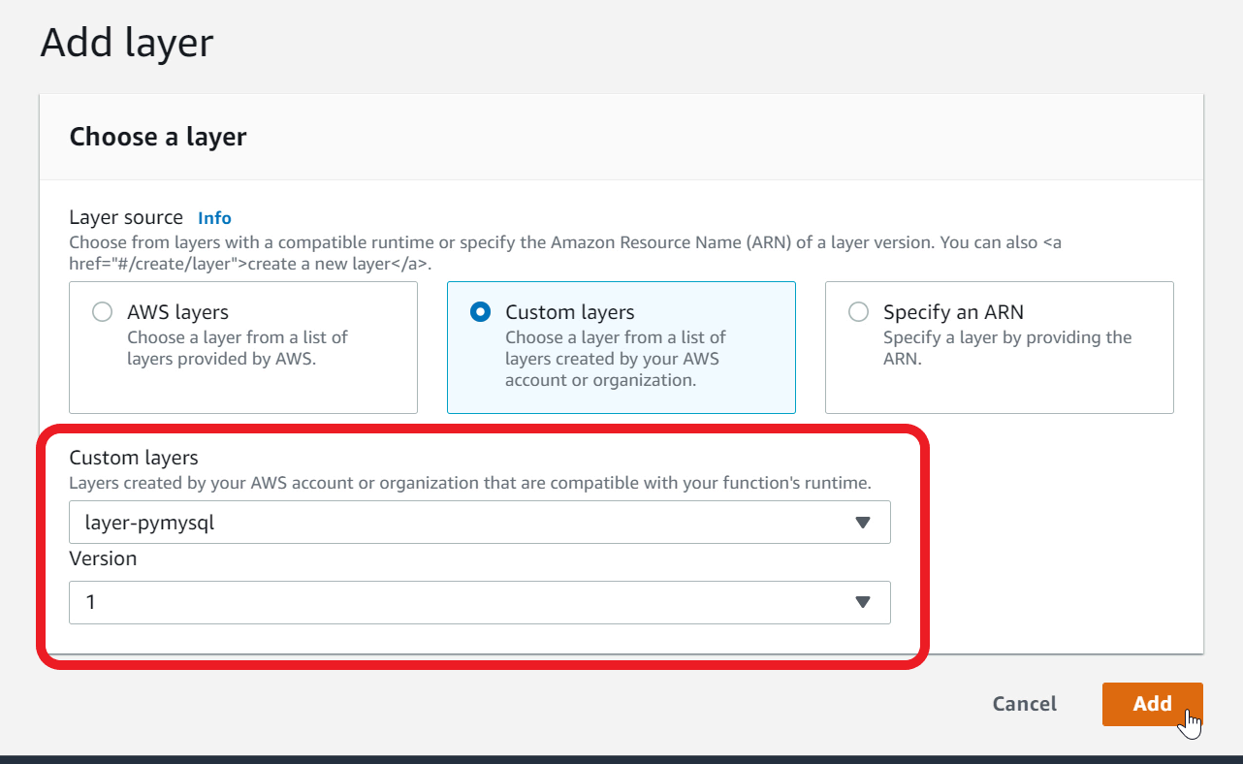

1. Click **Add**
2. You now need to add **RDS Proxy** to Lambda Function
3. Select **Configuration** tab

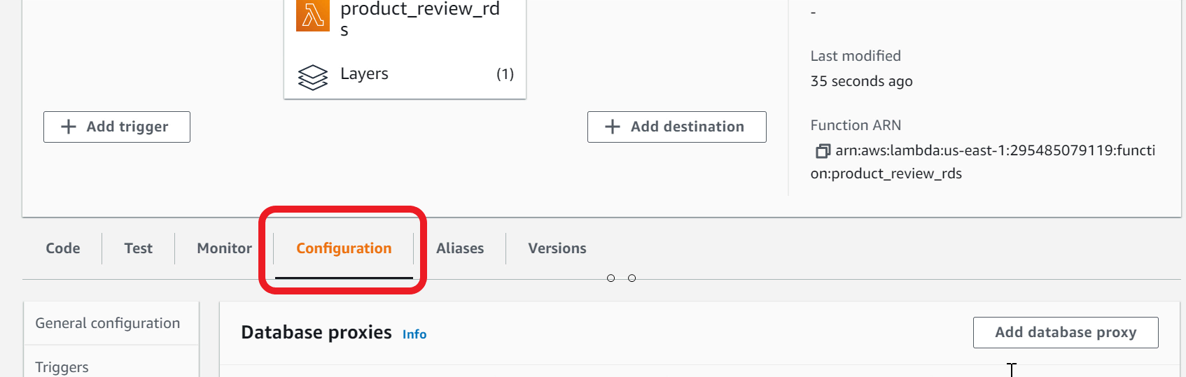

1. Select **Database proxies** in the navigation pane



1. Click **Add database proxy**
2. **Choose an existing proxy**
3. Select **productreviewproxy** from the drop down



1. Click **Add.**This will add necessary permissions to your Lambda IAM Role to call database proxy and acquire connection
2. Lambda function is now ready for integration test

Create an HTTP API in API Gateway

You will need to create an HTTP API in API Gateway. Ensure the API conforms to the design you did earlier. This API will be the front door for your web app to manage products and reviews. You also need to enable CORS (Cross Origin Resource Sharing) support for the API.

1. Open **API Gateway** console

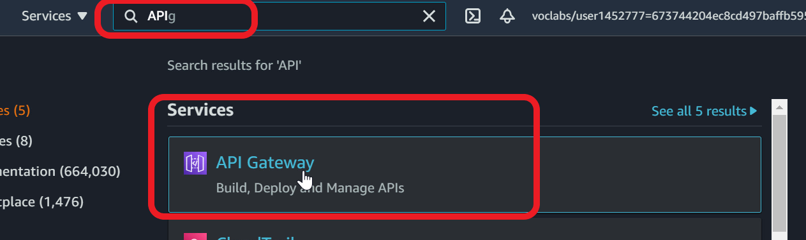

1. In the banner page, under **HTTP API**, Click **Build**

Note - if you don't see the banner page, click on **APIs** in the navigation pane and **Create API** and click **Build**under HTTP API

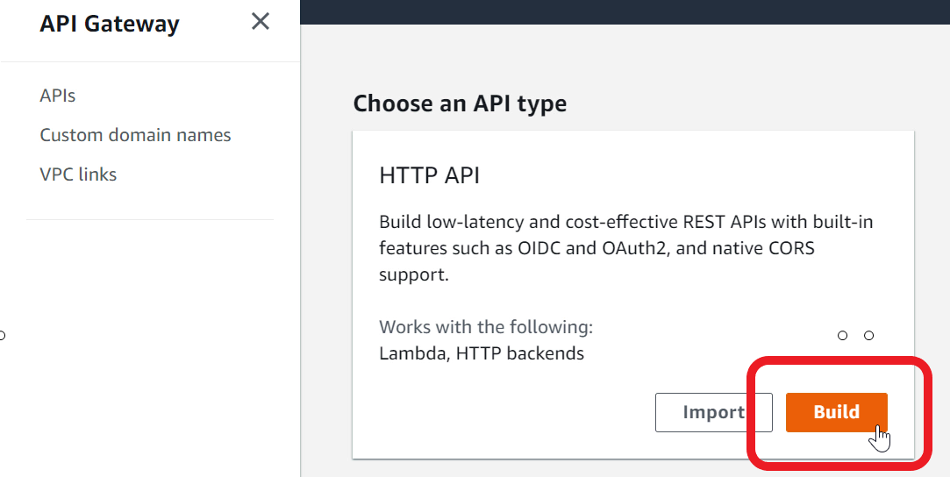

1. Under **Integrations** - Click **Add Integration**

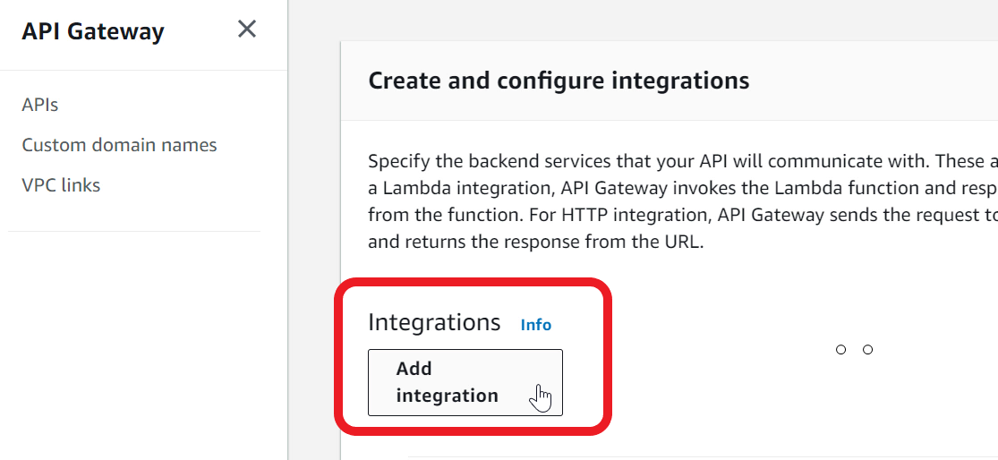

1. Choose **Lambda** from drop down
2. In the **Lambda function** - type **product_review_rds**

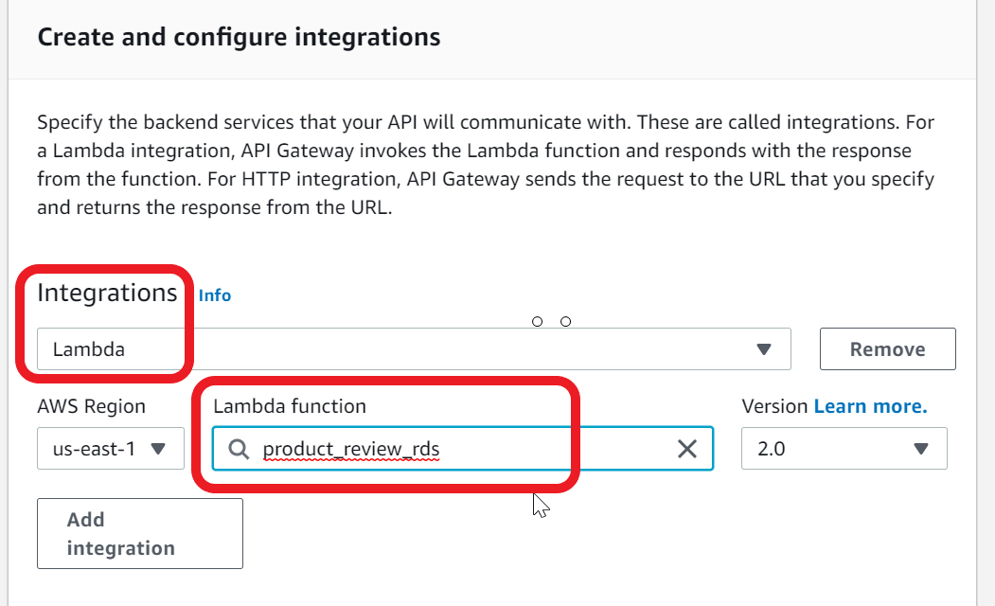

1. For **API name** - type **productReview**

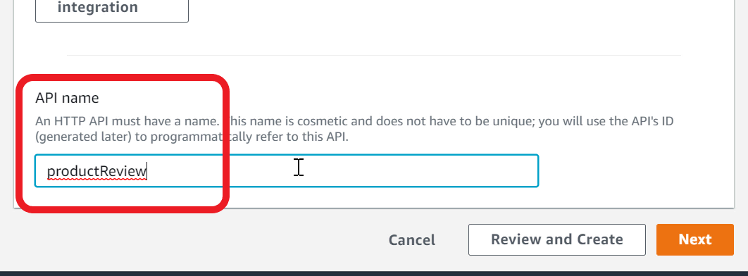

1. Go to the **Next** page
2. You can now configure the HTTP method, resource and integration target
3. For **Method**, select **GET**. For **Resource path** - type **/products.**For **Integration target**, ensure **product_review_rds** is selected

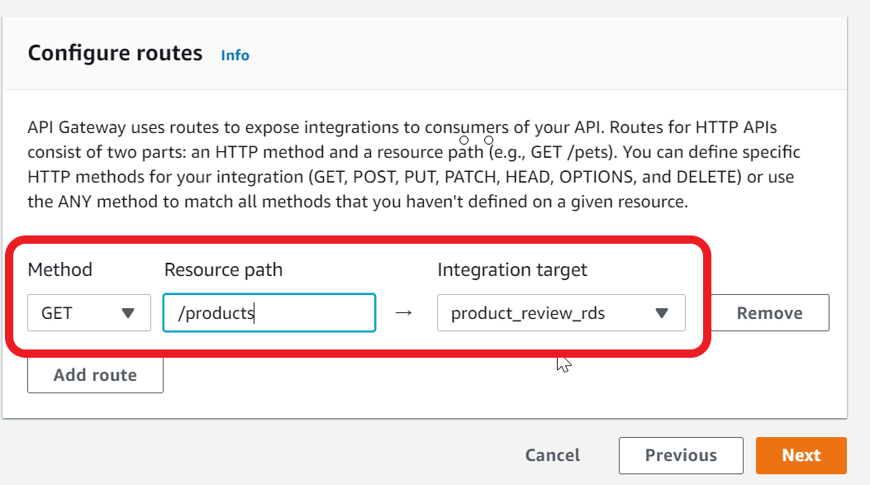

1. Click **Add route** to add all the routes with **integration target** **product_review_rds.**Ensure resource path matches exactly as specified below (including the case):
2. Method - POST, Resource path - /products
3. Method - PUT, Resource path - /products
4. Method - GET, Resource path - /products/{productId}
5. Method - DELETE, Resource path - /products/{productId}
6. Method - GET, Resource path - /products/{productId}/reviews
7. Method - POST, Resource path - /products/{productId}/reviews
8. Method - GET, Resource path - /products/{productId}/reviews/{reviewId}
9. The completed routes should look like

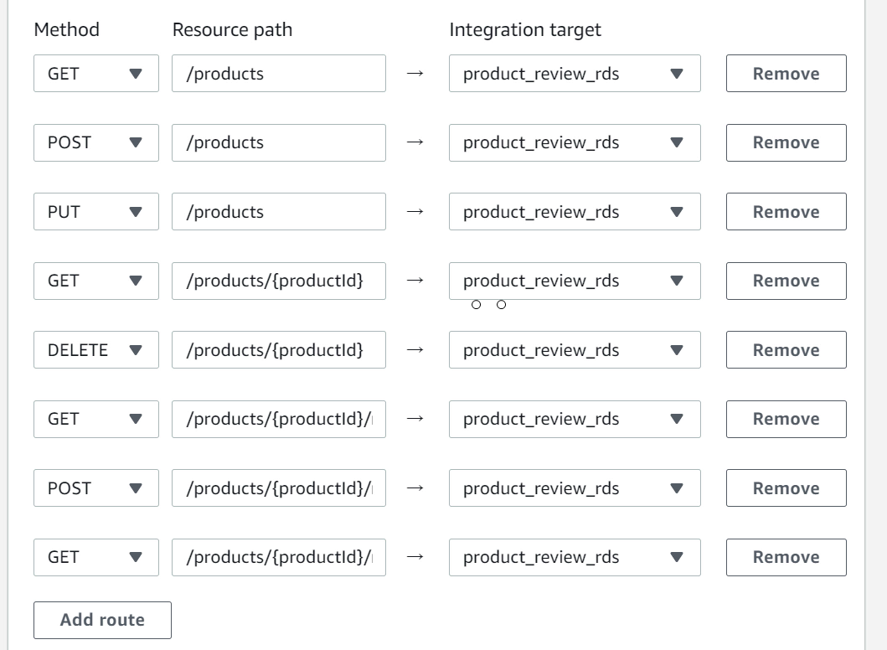

1. Go to **Next** page and continue to **Next** page
2. Review the routes and **Create**

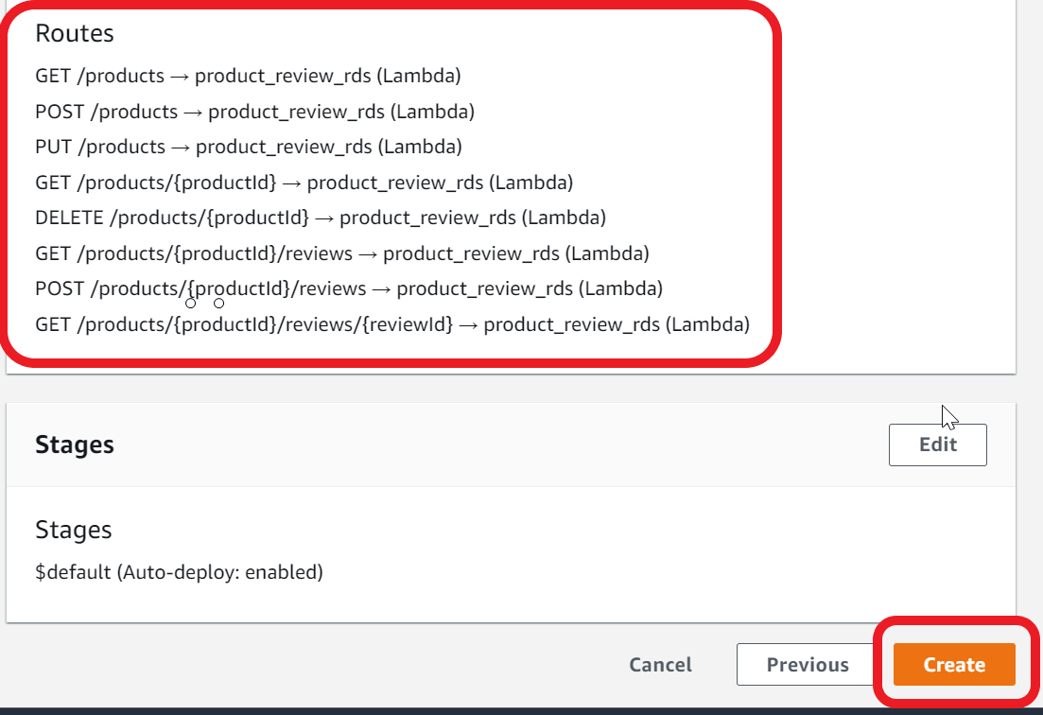

1. Select **Integrations** from the navigation pane. Here is what your route configuration should look like

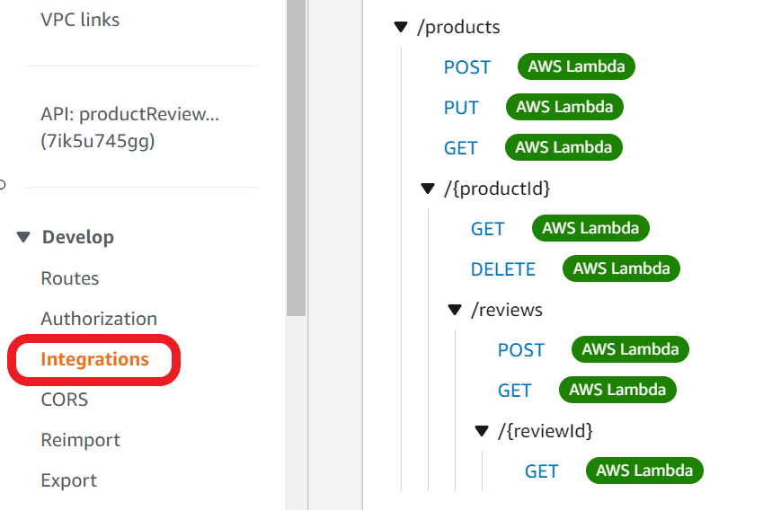

1. Select **CORS** from the navigation pane

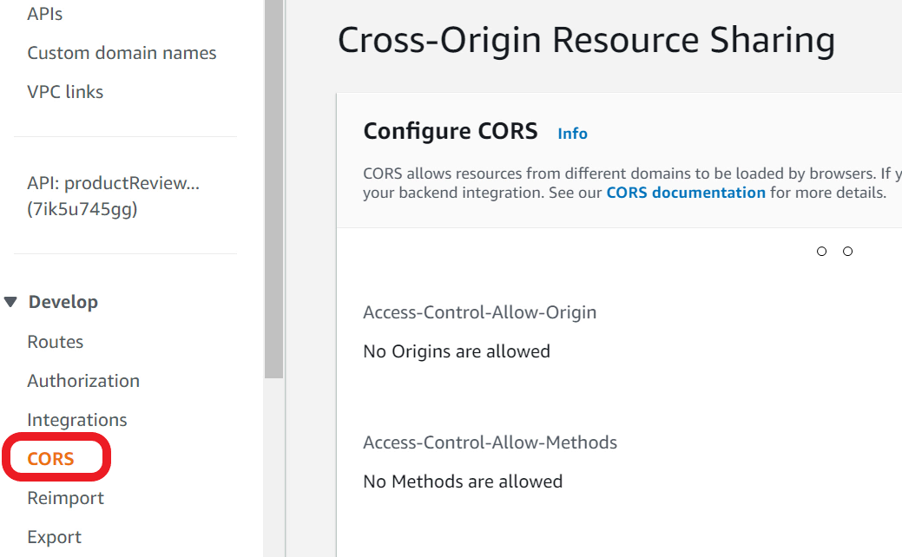

1. Click **Configure**

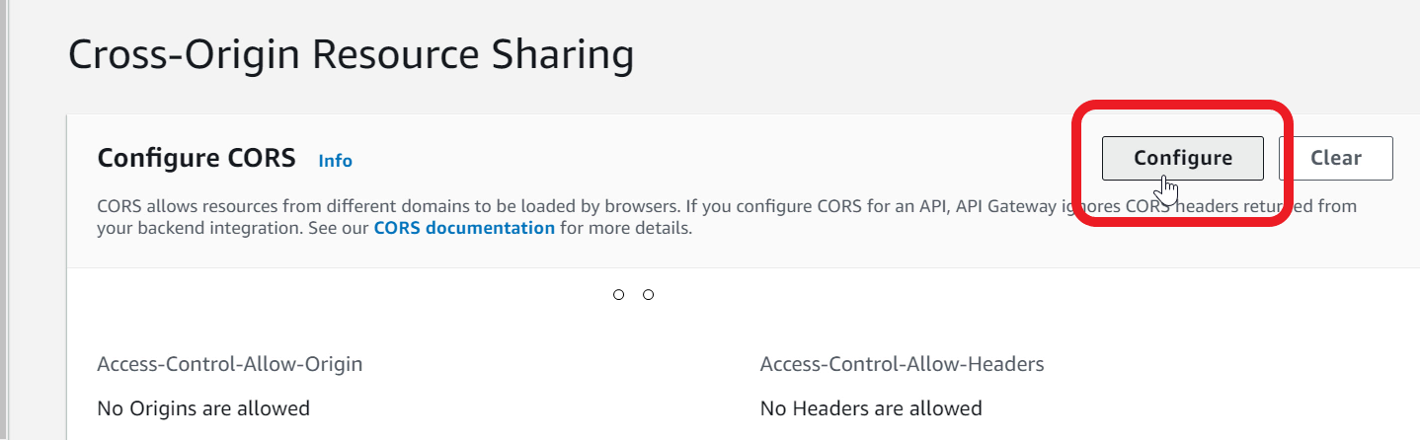

1. For **Access-Control-Allow-Origin** - type **\***
2. Click **Add**

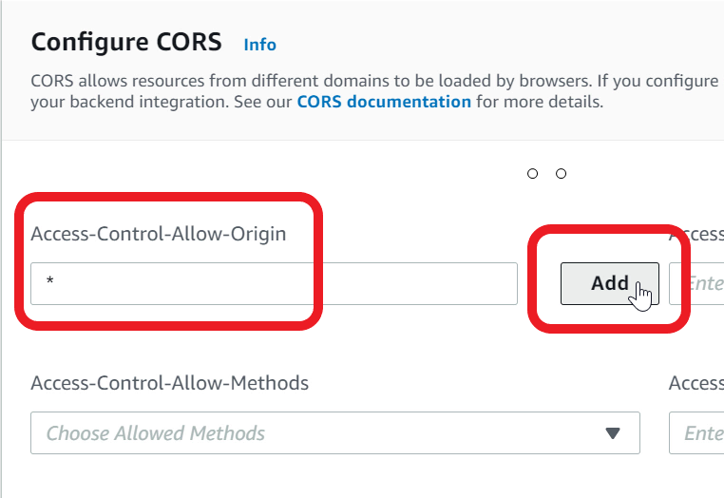

1. For **Access-Control-Allow-Methods** - Choose **\*** from the list

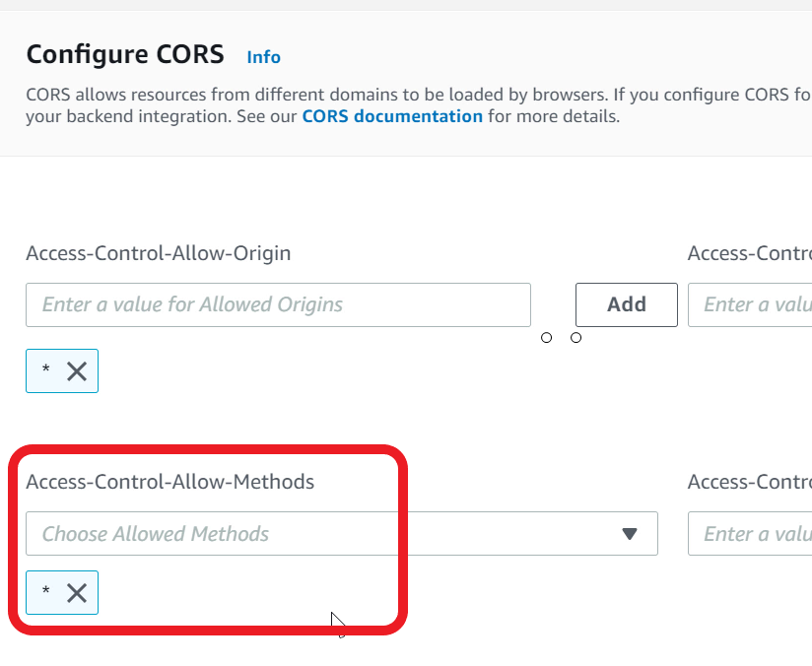

1. Click **Save**to save the CORS changes

Mark task as complete

Report issue

Integration Test using API Gateway

You can now perform an integration test using API Gateway Invoke URL. Invoke various API methods and check the **product_review_rds** Lambda function response.

1. Select your API from navigation pane
2. Copy the **Invoke URL**and save this as you would need this later

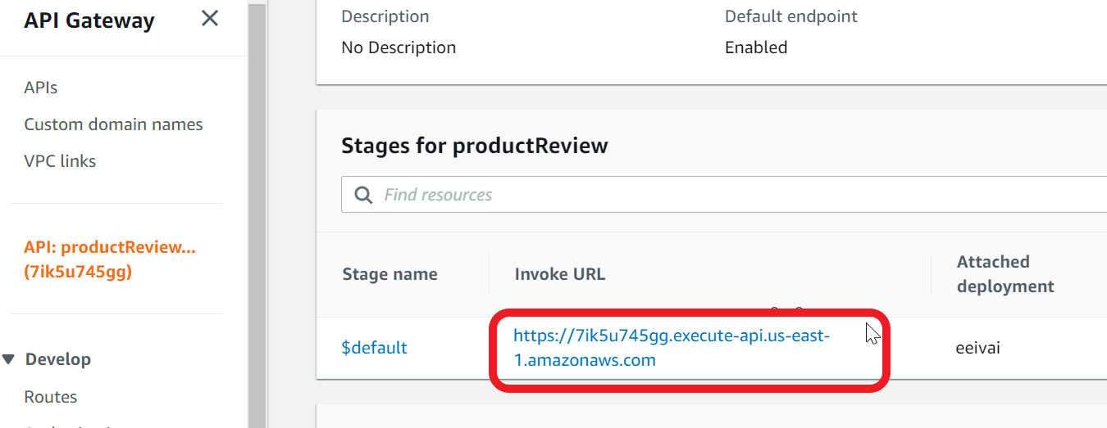

1. Paste the URL in the browser address bar
2. To read the list of products, use https://apigatewayinvokeurl**/products**

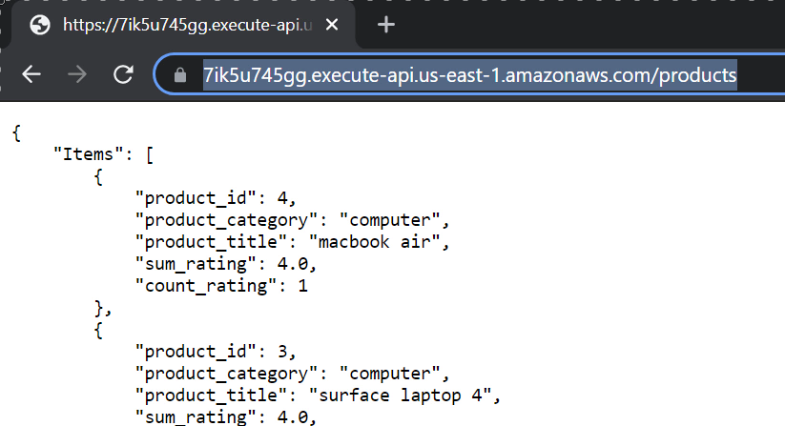

1. To read a specific product, specify the **productId**

https://apigatewayinvokeurl**/products/1**

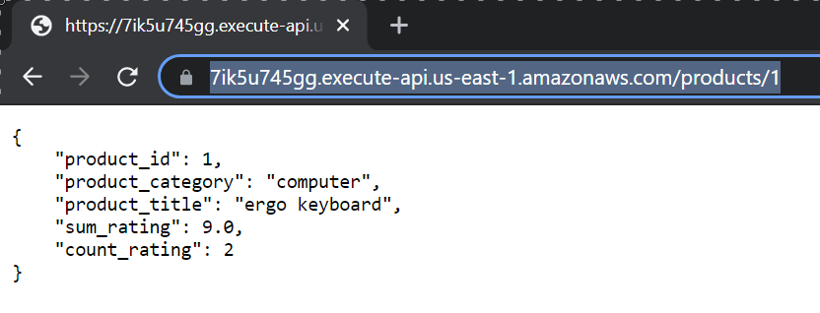

1. To read the reviews for a product, specify **reviews** resource

https://apigatewayinvokeurl**/products/1/reviews**

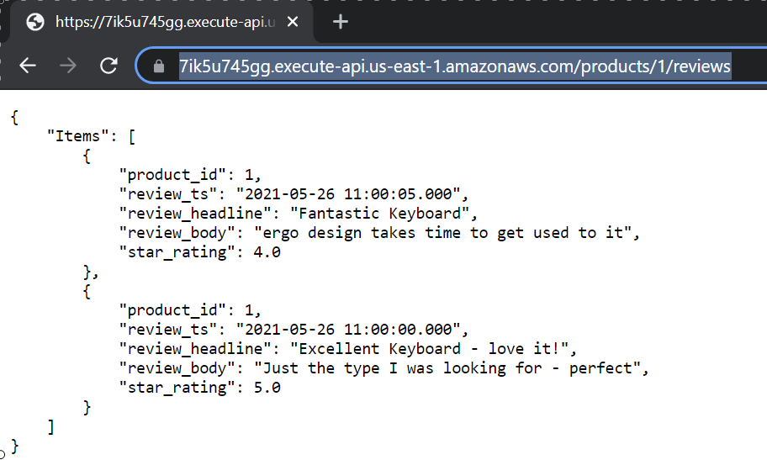

1. To read a specific review for a product, specify the review timestamp. You can copy the timestamp from the **review_ts** attribute

https://apigatewayinvokeurl**/products/1/reviews/2021-05-26 11:00:00.000**

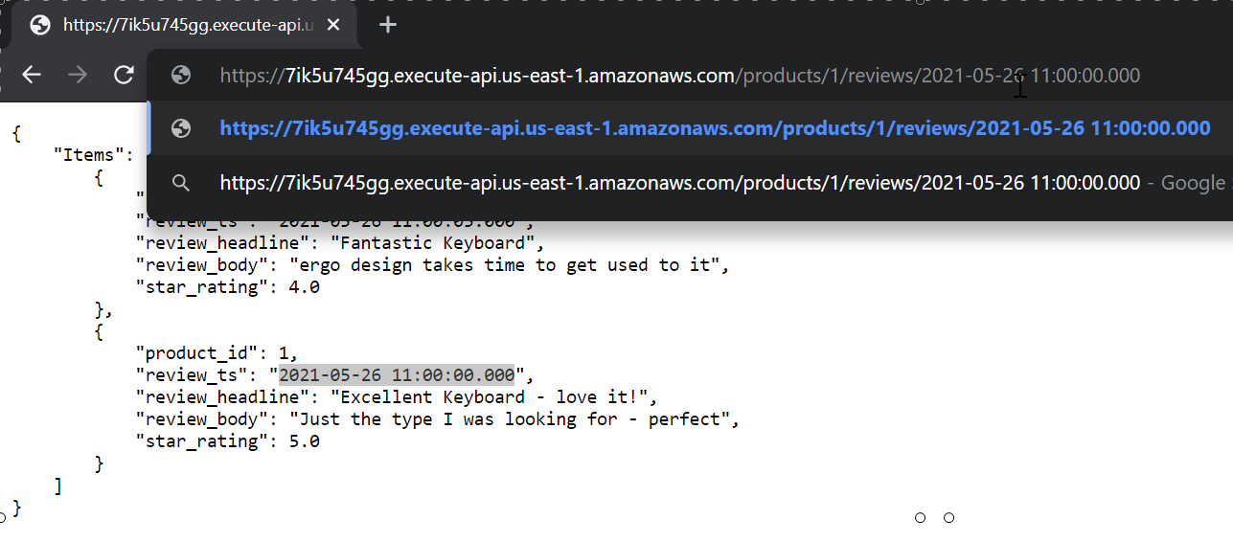

1. Optional - For POST, PUT and DELETE methods, you can use a tool like **Postman** or **RESTer**browser plug-in

<https://www.postman.com/downloads/>

<https://chrome.google.com/webstore/detail/rester/eejfoncpjfgmeleakejdcanedmefagga>

Configure a bucket in S3 to host your website

So far, you have built the API and the backend functionality. You can now work on a web client for product and review. You should use S3 for hosting your website. You need to create and configure an S3 bucket for website hosting.

1. Open **S3** console

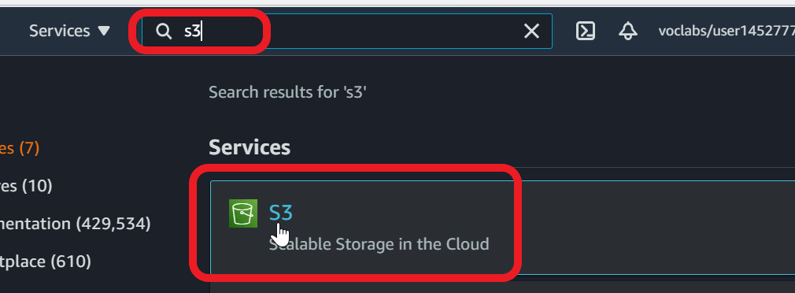

1. Click **Create bucket**

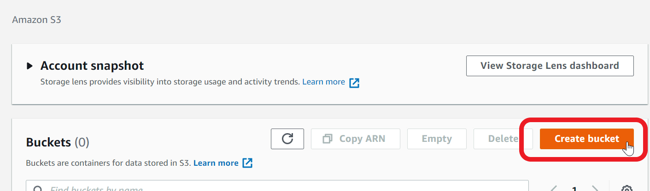

1. For **Bucket name** - specify a unique name. For example, productreview-randomvalue. If you get an error that name is not available, try a different random value.

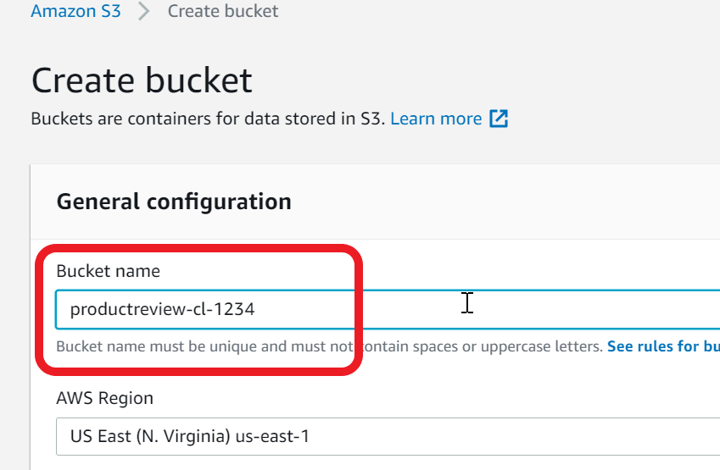

1. **Block all public access** - **uncheck**the checkbox. We need to allow public access as the bucket will be used for hosting a website

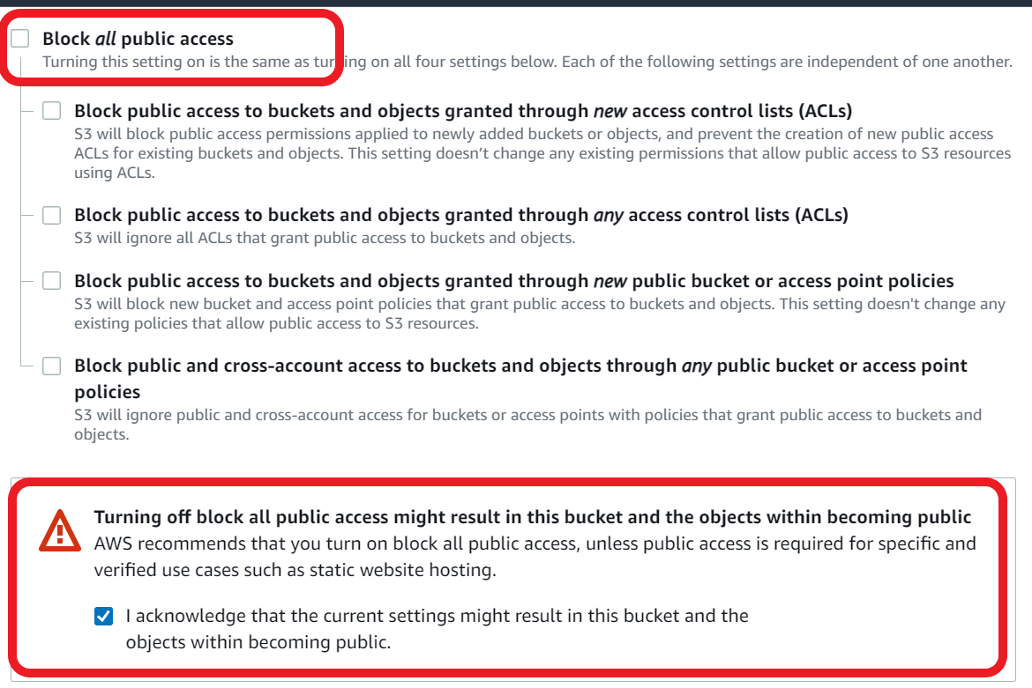

1. **Acknowledge** by selecting the checkbox that you want the bucket to be public
2. Click **Create bucket**
3. Click on the bucket name to open the details page

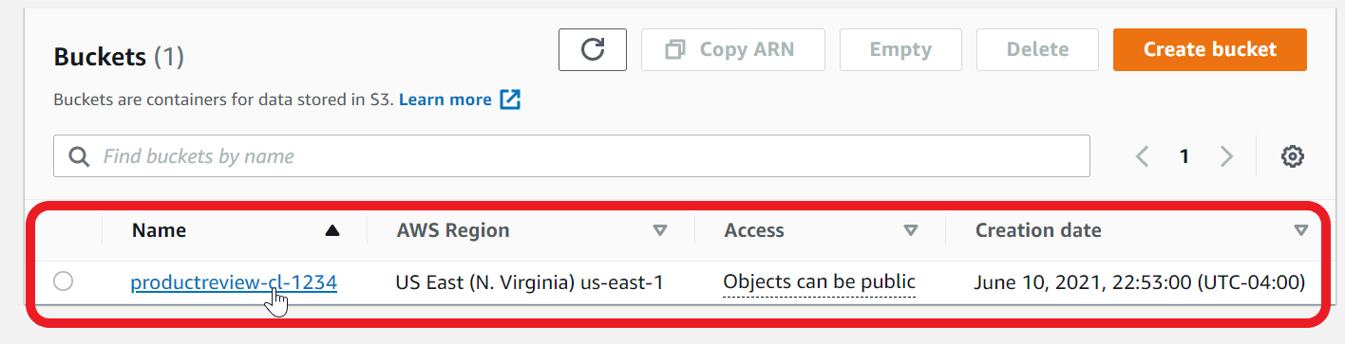

1. Go to the **Permissions** tab

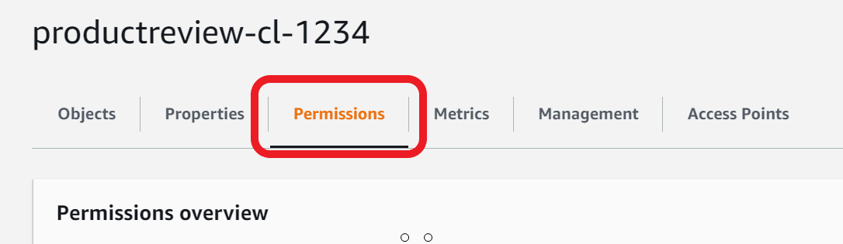

1. Scroll down to **Bucket policy**
2. Click **Edit**
3. Paste the below policy in the editor
4. {
5. "Version": "2012-10-17",
6. "Id": "Policy1621277578739",
7. "Statement": [
8. {
9. "Sid": "Stmt1621277577617",
10. "Effect": "Allow",
11. "Principal": "*",
12. "Action": "s3:GetObject",
13. "Resource": "arn:aws:s3:::your_bucket_name/*"
14. }
15. ]
16. }
17. In the policy, specify your bucket name in the resource attribute. Make sure**/\*** is there at the end

"Resource": "arn:aws:s3:::**your_bucket_name**/*"

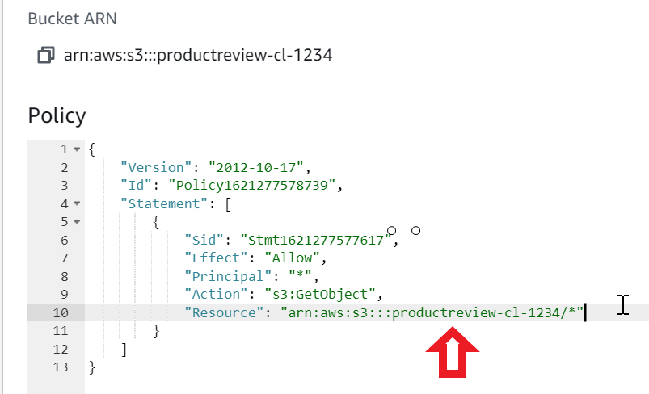

1. Click on **Save changes**
2. Go to **Properties** tab

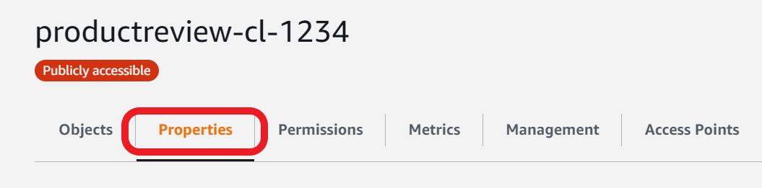

1. Scroll down to **Static website hosting**
2. Click **Edit**

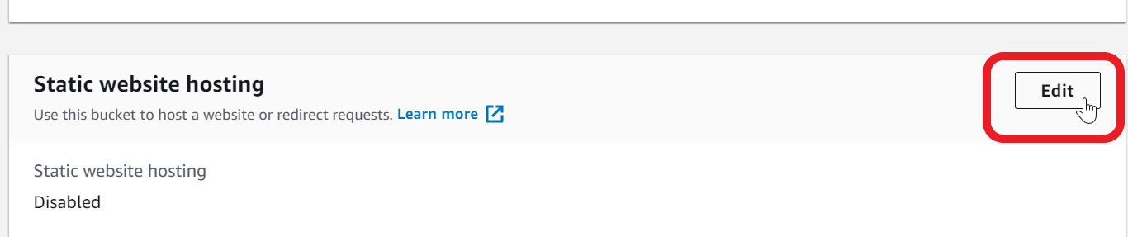

1. For **Static website hosting** - choose **Enable**
2. For **Hosting type** - select **Host a static website**

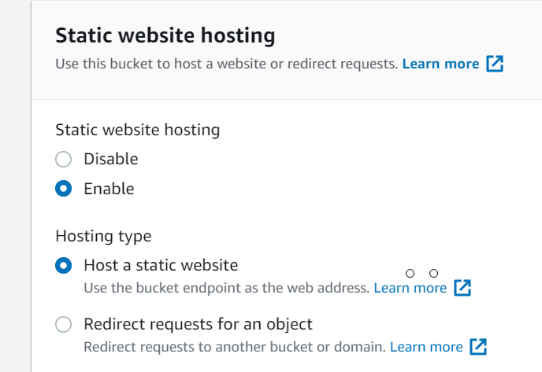

1. Specify **Index document** - type **index.html**

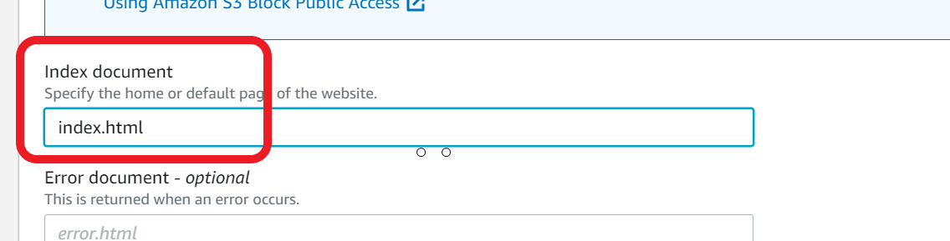

1. **Save changes**
2. Copy the **Bucket website endpoint**URLas you will need this to visit your website

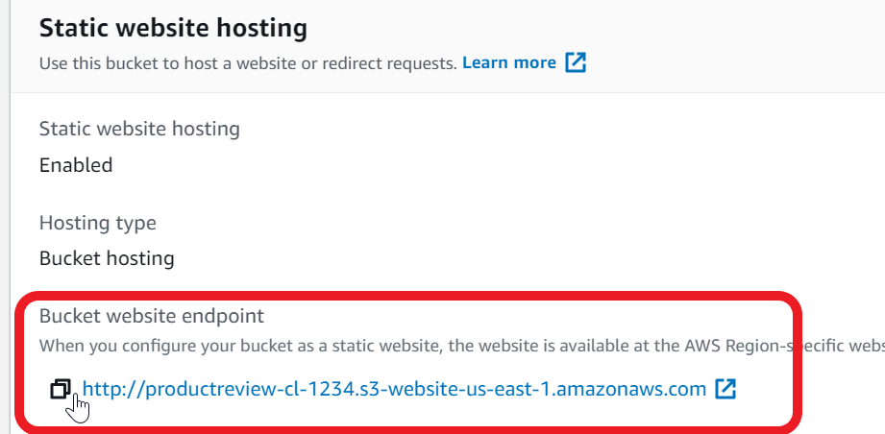

1. S3 bucket is now ready for hosting your web application

Upload webpage to S3

You now need to build a web client that talks to API Gateway for managing products and reviews. Once the web client is ready, upload to your S3 bucket.

1. Download the **WebPage.zip** file available in the Resources folder under assets
2. Open the zip file and extract the files to a local folder on your computer
3. The WebPage.zip contains an **index.html**page that is a single page client for product and review
4. Open the **index.html** in a text editor (use notepad, notepad++ or nano. Do not use editors like Word)

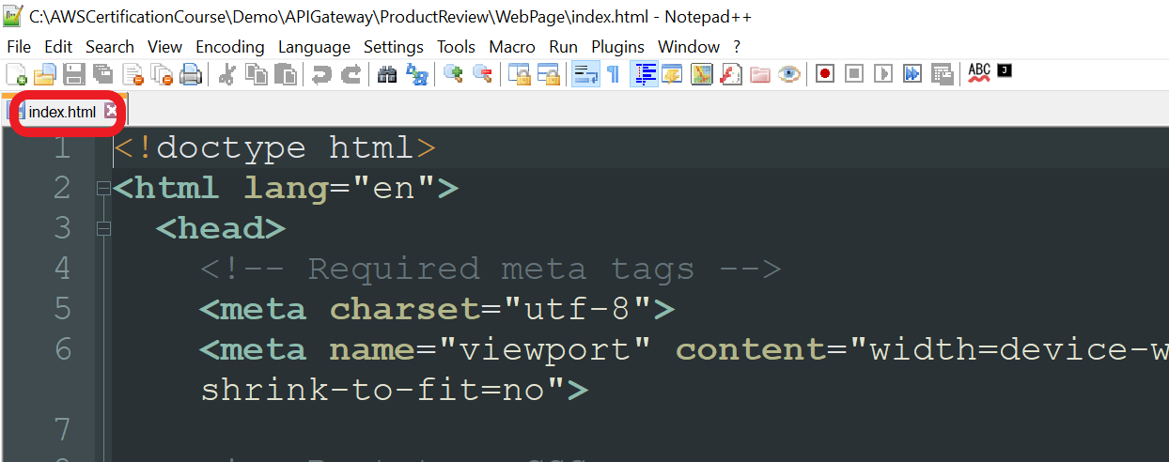

1. Look for the variable **API_GW_URI** in the **script** section

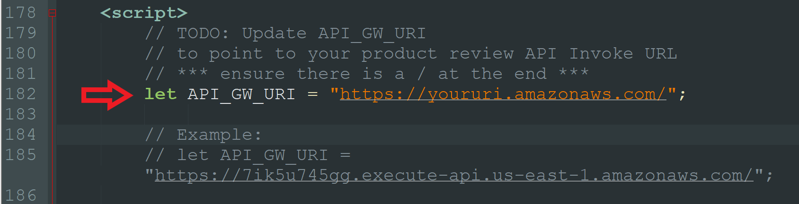

1. Update the value to point to **your product review API Gateway Invoke URL**. Ensure there is a**/**at the end. For example:

**let** **API_GW_URI** = "[**https://7ik5u745gg.execute-api.us-east-1.amazonaws.com/**](https://7ik5u745gg.execute-api.us-east-1.amazonaws.com/)";

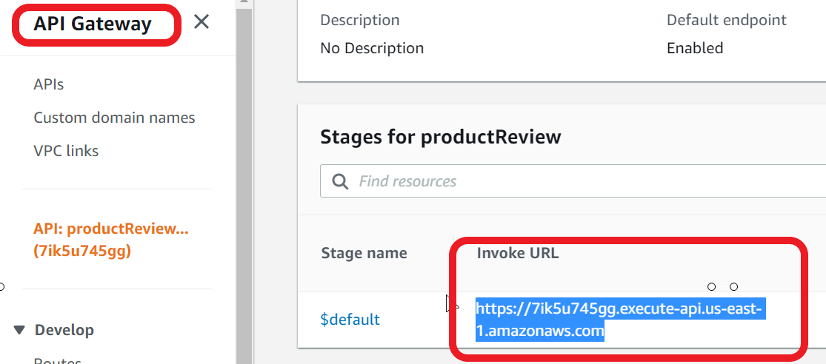

1. **Save** the changes

Note: You will get an error if you load this local file in your browser. Browser will not allow a local html file to talk to another domain. You can test from S3 or optionally use a tool like Visual Studio Code with Live Server plugin

1. In the **S3**console, open your S3 bucket
2. Click **Upload**

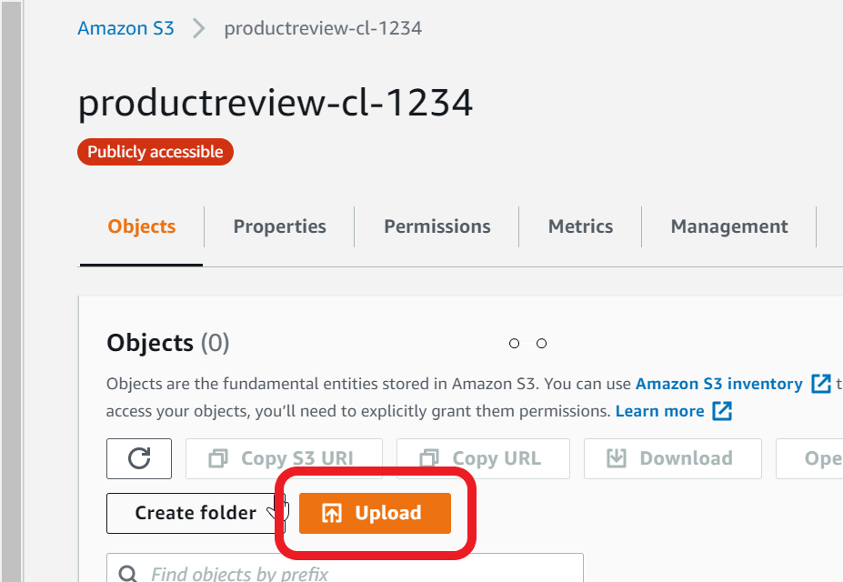

1. Click **Add files**
2. Select **index.html** on your local computer. This is the file that you modified in the earlier step
3. Click **Upload**
4. **Close** the window
5. Confirm **index.html**is in your bucket

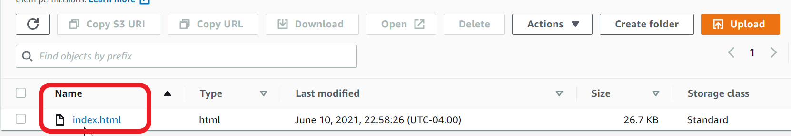

1. Your web app is now ready for testing

Ref Webpage.zip

Visit the product-review website and test all features

You must now test all the features for managing products and reviews.

1. Visit **Bucket website endpoint**from your browser**.**This URL is available in **S3** bucket **Properties** tab, **Static website hosting**



1. The web page will talk to the API Gateway and list available products

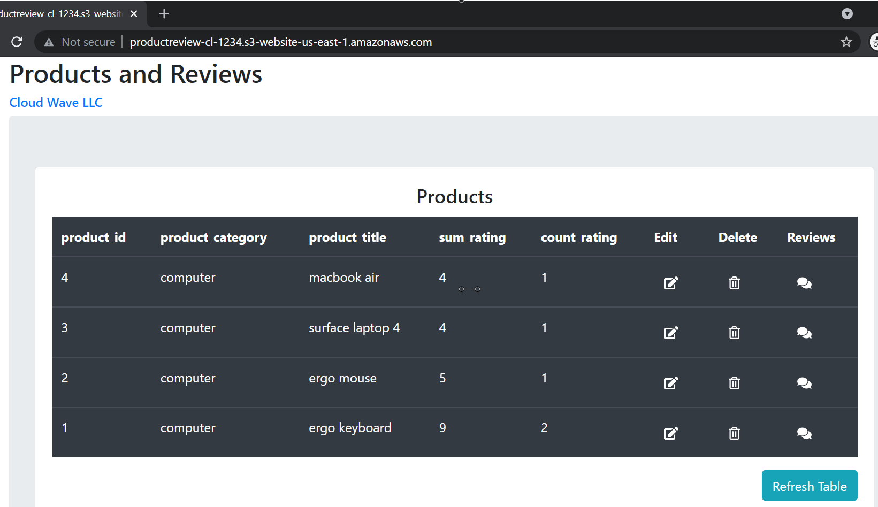

1. To view reviews for a product, click on the **review** icon

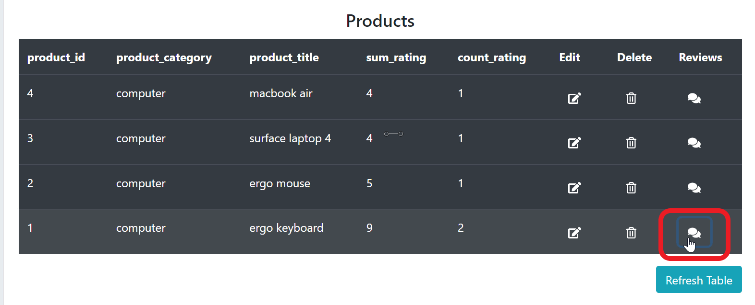

1. You can now see reviews for the selected product

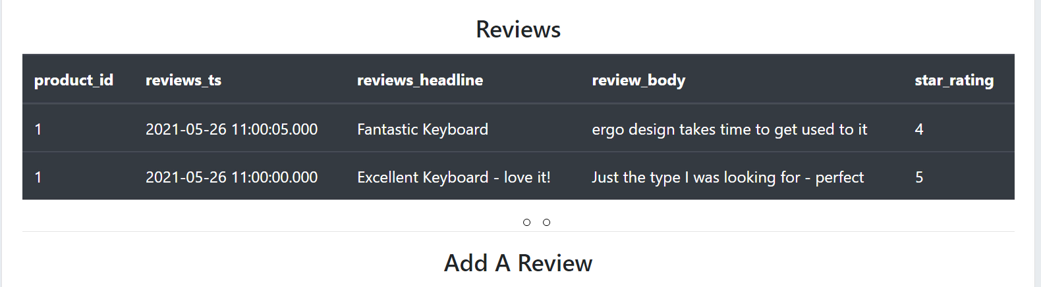

1. To add product, go the Add / Edit Product section

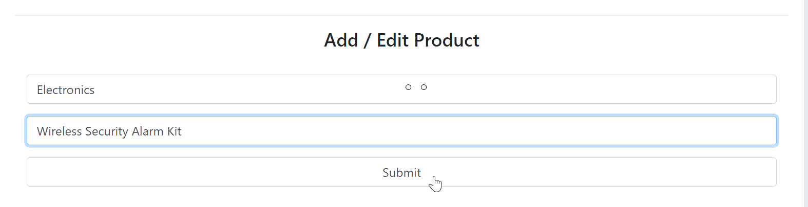

1. Specify values for Product Category and Product title
2. Click **Submit**
3. The newly added product is listed at the top in the products table

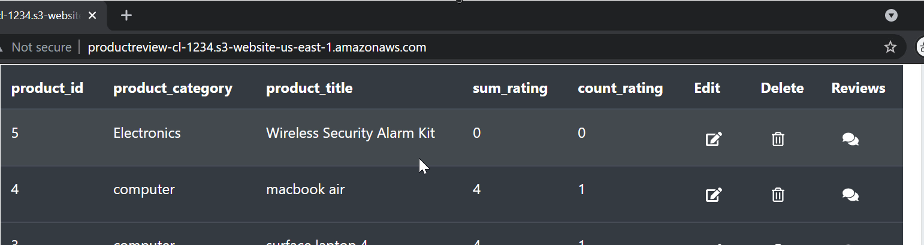

1. To add a review for the product, click on review icon
2. Specify values for **Review headline**, **Review body**, provide a numeric value for **Star Rating** and click **Submit**

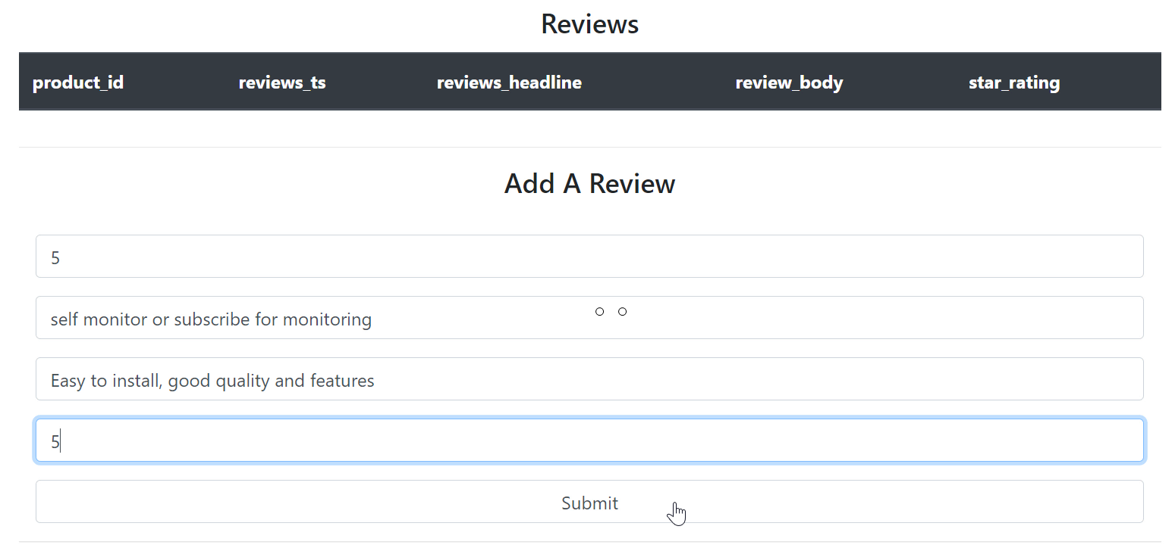

1. You can see the newly added review in the review table

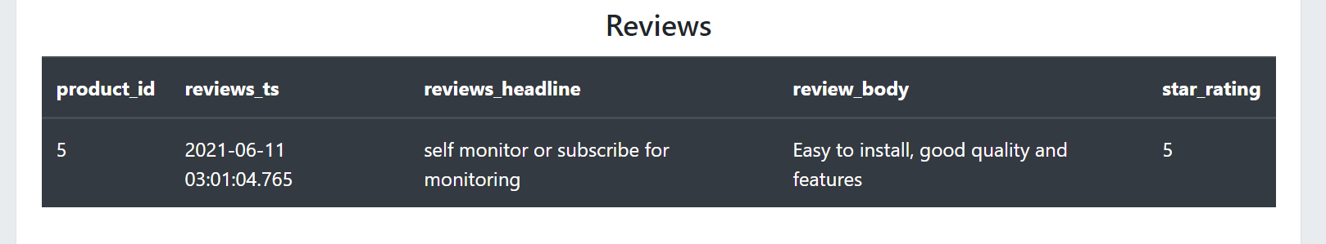

1. You can also filter reviews for a product by star rating
2. Click the review icon for a product, and scroll down to the **Filter reviews By Star Rating** section. Specify value for star rating. For example, if you specify a value 4, it will list all reviews for the product that are rated 4-star or above.

Clean Up

You need to now clean up all the resources. Remove the S3 bucket, API, Lambda functions, Database Proxy and the Aurora Database instance.

1. Open **S3** Console
2. Select your bucket
3. Click **Empty** and follow the prompt to empty the bucket
4. You can now click **Delete** to remove the bucket
5. Open **API Gateway** Console
6. Select **productReview** API
7. From **Actions** dropdown, choose **Delete**
8. Open **Lambda** Console
9. Select **product_review_rds** function
10. From **Actions** dropdown, choose **Delete**
11. Select **product_review_healthcheck** function
12. From **Actions** dropdown, choose **Delete**
13. Open **RDS** console
14. Click **Proxies** from navigation pane
15. Select **productreviewproxy**
16. From the **Actions** dropdown, choose **Delete.**Follow the prompt to delete
17. Click **Databases** from navigation pane
18. Select **demodatabase-instance-1**
19. From the **Actions** dropdown, choose **Delete**
20. Uncheck **Create final snapshot** and **Acknowledge**and follow the prompt to delete